**1.INTRODUCTION**

With the rapid development of reputation systems in various online social networks, manipulations against such systems are evolving quickly. In this paper, we propose scheme TATA, the abbreviation of joint Temporal And Trust Analysis, which protects reputation systems from a new angle: the combination of time domain anomaly detection and Dempster–Shafer theory-based trust computation. Real user attack data collected from a cyber competition is used to construct the testing data set. Compared with two representative reputation schemes and our previous scheme, TATA achieves a signiﬁcantly better performance in terms of identifying items under attack, detecting malicious users who insert dishonest ratings, and recovering reputation scores.

**Organization Profile**

**COMPANY PROFILE:**

Founded in 2009, LotusTechnologies located at Pondicherry, has a rich background in developing academic student projects, especially in solving latest Papers, Software Development and continues its entire attention on achieving transcending excellence in the Development and Maintenance of Software Projects and Products in Many Areas.

In Today's Modern Technological Competitive Environment, Students in Computer Science Stream Want To Ensure That They Are Getting Guidance In An Organization That Can Meet Their Professional Needs. With Our Well Equipped Team of Solid Information Systems Professionals, Who Study, Design, Develop, Enhance, Customize, Implement, Maintain and Support Various Aspects Of Information Technology, Students Can Be Sure.

We Understand The Students’ Needs, And Develop Their Quality Of Professional Life By Simply Making The Technology Readily Usable For Them. We Practice Exclusively in Software Development, Network Simulation, Search Engine Optimization, Customization And System Integration. Our Project Methodology Includes Techniques For Initiating A Project, Developing The Requirements, Making Clear Assignments To The Project Team, Developing A Dynamic Schedule, Reporting Status To Executives And Problem Solving.

The indispensable factors, which give the competitive advantages over others in the market, may be slated as:

* Performance
* Pioneering efforts
* Client satisfaction
* Innovative concepts
* Constant Evaluations
* Improvisation
* Cost Effectiveness

**About The People:**

As a team we have the clear vision and realize it too. As a statistical evaluation, the team has more than 40,000 hours of expertise in providing real-time solutions in the fields of Android Mobile Apps Development, Networking, Web Designing, Secure Computing, Mobile Computing, Cloud Computing, Image Processing And Implementation, Networking With OMNET++ Simulator, client Server Technologies in Java,(J2EE\J2ME\EJB), ANDROID, DOTNET (ASP.NET, VB.NET, C#.NET), MATLAB, NS2, SIMULINK, EMBEDDED, POWER ELECTRONICS, VB & VC++, Oracle and operating system concepts with LINUX.

**Our Vision:**

**“Impossible as Possible”** this is our vision; we work according to our vision

**2.SYSTEM ANALYSIS**

**2.1 INTRODUCTION TO SYSTEM ANALYSIS**

**2.1.1 EXISTING SYSTEM:**

Introduction more people use the Internet for entertainment, building personal relationships, and conducting businesses, the Internet has created vast opportunities for online interactions. However, due to the anonymity of the Internet, it is very difﬁcult for normal users to evaluate a stranger’s trustworthiness and quality, which makes online interactions risky. Is a piece of news on Reddit true? Does a product atAmazon.com have high quality as described? Is a video on YouTube really interesting or informative? In most cases, the answers can hardly be predicted before the interactions are committed. The problem is how the online participants protect themselves by judging the quality of strangers or unfamiliar items beforehand.

**DISADVANTAGES OF EXISTING SYSTEM:**

1.online reputation systems have been built up. The goal is to create large-scale virtual word-of-mouth networks where individuals share opinions and experiences, in terms of reviews and ratings, on various *items*, including products, services, digital contents and even other people.

2.These opinions and experiences, which are called users’ *feedback*, are collected as evidence, and are analyzed, aggregated, and disseminated to general users. The disseminated results are called *reputation score*. Such systems are also referred to as *feedback based reputation systems*.

**2.1.2 PROPOSED SYSTEM:**

In this paper, we propose a reputation defense scheme, named TATA, for feedback-based reputation systems. Here, TATA is the abbreviation of joint Temporal And Trust Analysis .It contains two modules: *a time domain anomaly detector* and *a trust model based on the Dempster–Shafer theory*. Speciﬁcally, we consider the ratings to a given item as a time sequence, and a time domain anomaly detector is introduced to detect suspicious time intervals where anomaly occurs. A trust analysis is then conducted based on the anomaly detection results. We borrow the concept of user *behavior uncertainty* from the Dempster–Shafer theory to model users’ behavior patterns, and evaluate whether a user’s rating value to each item is reliable or not.

**ADVANTAGES OF PROPOSED SYSTEM:**

The objective of the proposed scheme is to

(1) detect the malicious users who provide dishonest ratings;

(2) recover reputation score of the target item, that receives dishonest ratings;

(3) avoid interference to normal items’ reputation scores. Speciﬁcally, TATA is a combination of an anomaly detector,

**MODULES:**

1.Temporal Analysis—Change Detector

2.Joint Temporal And Trust Analysis (TATA)

3.System Model

4.Attack Model

**MODULES DESCSRIPTION:**

**TEMPORAL ANALYSIS—CHANGE DETECTOR:**

Many change detectors have been developed for different application scenarios .In online reputation systems, since normal ratings do not necessarily follow a speciﬁc distribution and attackers may insert dishonest ratings with small bias, we need to choose a change detector that is insensitive to the probability distribution of data and is able to reliably detect small shifts. Therefore, we choose the CUSUM detector which fulﬁlls these requirements, as the base to build our change detector.

In the temporal analysis, we organize the ratings to a given item as a sequence in the descending order according to the time when they are provided. In many practical reputation systems, items have intrinsic and stable quality, which should be reflected in the distribution of normal ratings. Therefore, rapid changes can serve as indicators of anomaly. We propose a revised CUSUM detector as the anomaly detector, which reliably detects changes occurring in the rating sequences of an online item.

**JOINT TEMPORAL AND TRUST ANALYSIS (TATA):**

In TATA, we propose to detect anomaly from a new angle: analyzing time domain information. Speciﬁcally, we organize the ratings to a given item as a sequence in the descending order according to the time when they are provided. This sequence, denoted by, actually reﬂects the rating trend to the given item. As mentioned in Section III, in practice, many items have intrinsic and stable quality, which should be reﬂected in the distribution of normal ratings. If there are rapid changes in the rating values, such changes can serve as indicators of anomaly. Therefore, we propose a **change detector** i n TATA as t he anomaly detector, which takes the rating sequences as inputs and detects changes occurring in the rating sequences. The proposed change detector will detect not only sudden rapid changes but also small changes accumulated over time. In this way, even if malicious users insert dishonest ratings with small shifts to gradually mislead items’ reputation scores, such type of changes will still be accumulated and ﬁnally be detected by the proposed change detector

**SYSTEM MODEL:**

We model the feedback-based reputation systems as the system in which *users* provide ratings to *items*. This model can describe many practical systems. For example, buyers provide ratings to products on Amazon.com, and readers rate social news on Reddit.com. The items in above systems are products and social news, respectively. We consider that each user will provide rating to one item at most once, and the rating values are integer values ranging from 1 to 5. In practice, reputation systems often allow users to provide reviews as well. These reviews can also be untruthful. In this paper, we focus on the detection of dishonest ratings. The analysis of untruthful reviews is beyond the scope of this paper, whereas the dishonest rating detection and untruthful review detection complement each other.

**ATTACK MODEL:**

*Attack Model:* An *attacker* can control one or multiple user IDs and each of these user IDs is referred to as a *malicious user*. Malicious users provide ratings to manipulate the reputation score of items. The item whose reputation score is manipulated by malicious users is called a *target item*. The ratings provided by malicious users to target items are considered as *dishonest ratings*. An *attack proﬁle* describes the behavior of all malicious users controlled by the attacker.

**2.2. FEASIBILITY STUDY**

The feasibility of the project is analyzed in this phase and business proposal is put forth with a very general plan for the project and some cost estimates. During system analysis the feasibility study of the proposed system is to be carried out. This is to ensure that the proposed system is not a burden to the company. For feasibility analysis, some understanding of the major requirements for the system is essential.

Three key considerations involved in the feasibility analysis are

* ECONOMICAL FEASIBILITY
* TECHNICAL FEASIBILITY
* SOCIAL FEASIBILITY
* **ECONOMICAL FEASIBILITY**

This study is carried out to check the economic impact that the system will have on the organization. The amount of fund that the company can pour into the research and development of the system is limited. The expenditures must be justified. Thus the developed system as well within the budget and this was achieved because most of the technologies used are freely available. Only the customized products had to be purchased.

### TECHNICAL FEASIBILITY

This study is carried out to check the technical feasibility, that is, the technical requirements of the system. Any system developed must not have a high demand on the available technical resources. This will lead to high demands on the available technical resources. This will lead to high demands being placed on the client. The developed system must have a modest requirement, as only minimal or null changes are required for implementing this system.

* **SOCIAL FEASIBILITY**

The aspect of study is to check the level of acceptance of the system by the user. This includes the process of training the user to use the system efficiently. The user must not feel threatened by the system, instead must accept it as a necessity. The level of acceptance by the users solely depends on the methods that are employed to educate the user about the system.

**2.3 REQUIREMENTS SPECIFICATION**

Use this Requirements Specification template to document the requirements for your product or service, including priority and approval. Tailor the specification to suit your project, organizing the applicable sections in a way that works best, and use the checklist to record the decisions about what is applicable and what isn't.

The format of the requirements depends on what works best for your project.

This document contains instructions and examples which are for the benefit of the person writing the document and should be removed before the document is finalized.

To regenerate the TOC, select all (CTL-A) and press F9.

Executive Summary

**Project Overview**

Describe this project or product and its intended audience, or provide a link or reference to the project charter.

**Purpose and Scope of this Specification**

Describe the purpose of this specification and its intended audience. Include a description of what is within the scope what is outside of the scope of these specifications. For example:

**In scope**

This document addresses requirements related to phase 2 of Project A:

modification of Classification Processing to meet legislative mandate ABC.

modification of Labor Relations Processing to meet legislative mandate ABC.

**Out of Scope**

The following items in phase 3 of Project A are out of scope:

modification of Classification Processing to meet legislative mandate XYZ.

modification of Labor Relations Processing to meet legislative mandate XYZ.

(Phase 3 will be considered in the development of the requirements for Phase 2, but the Phase 3 requirements will be documented separately.)

Product/Service Description

In this section, describe the general factors that affect the product and its requirements. This section should contain background information, not state specific requirements (provide the reasons why certain specific requirements are later specified).

**Product Context**

How does this product relate to other products? Is it independent and self-contained? Does it interface with a variety of related systems? Describe these relationships or use a diagram to show the major components of the larger system, interconnections, and external interfaces.

**User Characteristics**

Create general customer profiles for each type of user who will be using the product. Profiles should include:

Student/faculty/staff/other

experience

technical expertise

other general characteristics that may influence the product

**Assumptions**

List any assumptions that affect the requirements, for example, equipment availability, user expertise, etc. For example, a specific operating system is assumed to be available; if the operating system is not available, the Requirements Specification would then have to change accordingly.

**Constraints**

Describe any items that will constrain the design options, including

parallel operation with an old system

audit functions (audit trail, log files, etc.)

access, management and security

criticality of the application

system resource constraints (e.g., limits on disk space or other hardware limitations)

other design constraints (e.g., design or other standards, such as programming language or framework)

**Dependencies**

List dependencies that affect the requirements. Examples:

This new product will require a daily download of data from X,

Module X needs to be completed before this module can be built.

Requirements

Describe all system requirements in enough detail for designers to design a system satisfying the requirements and testers to verify that the system satisfies requirements.

Organize these requirements in a way that works best for your project. See ,

Organizing the **Requirements** for different ways to organize these requirements.

Describe every input into the system, every output from the system, and every function performed by the system in response to an input or in support of an output. (Specify what functions are to be performed on what data to produce what results at what location for whom.)

Each requirement should be numbered (or uniquely identifiable) and prioritized.

See the sample requirements in , and , as well as these example priority definitions:

**Priority Definitions**

The following definitions are intended as a guideline to prioritize requirements.

Priority 1 – The requirement is a “must have” as outlined by policy/law

Priority 2 – The requirement is needed for improved processing, and the fulfillment of the requirement will create immediate benefits

Priority 3 – The requirement is a “nice to have” which may include new functionality

It may be helpful to phrase the requirement in terms of its priority, e.g., "The value of the employee status sent to DIS **must be** either A or I" or "It **would be nice** if the application warned the user that the expiration date was 3 business days away". Another approach would be to group requirements by priority category.

A good requirement is:

Correct

Unambiguous (all statements have exactly one interpretation)

Complete (where TBDs are absolutely necessary, document why the information is unknown, who is responsible for resolution, and the deadline)

Consistent

Ranked for importance and/or stability

Verifiable (avoid soft descriptions like “works well”, “is user friendly”; use concrete terms and specify measurable quantities)

Modifiable (evolve the Requirements Specification only via a formal change process, preserving a complete audit trail of changes)

Does not specify any particular design

Traceable (cross-reference with source documents and spawned documents).

**Functional Requirements**

In the example below, the requirement numbering has a scheme - BR_LR_0## (BR for Business Requirement, LR for Labor Relations). For small projects simply BR-## would suffice. Keep in mind that if no prefix is used, the traceability matrix may be difficult to create (e.g., no differentiation between '02' as a business requirement vs. a test case)

The following table is an example format for requirements. Choose whatever format works best for your project.

**User Interface Requirements**

In addition to functions required, describe the characteristics of each interface between the product and its users (e.g., required screen formats/organization, report layouts, menu structures, error and other messages, or function keys).

**Usability**

Include any specific usability requirements, for example,

Learnability

The user documentation and help should be complete

The help should be context sensitive and explain how to achieve common tasks

The system should be easy to learn

(See <http://www.usabilitynet.org/>)

**Performance**

Specify static and dynamic numerical requirements placed on the system or on human interaction with the system:

Static numerical requirements may include the number of terminals to be supported, the number of simultaneous users to be supported, and the amount and type of information to be handled.

Dynamic numerical requirements may include the number of transactions and tasks and the amount of data to be processed within certain time period for both normal and peak workload conditions.

All of these requirements should be stated in measurable form. For example, "95% of the transactions shall be processed in less than 1 second" rather than “an operator shall not have to wait for the transaction to complete”.

**Capacity**

Include measurable capacity requirements (e.g., the number of simultaneous users to be supported, the maximum simultaneous user load, per-user memory requirements, expected application throughput)

**Availability**

Include specific and measurable requirements for:

Hours of operation

Level of availability required

Coverage for geographic areas

Impact of downtime on users and business operations

Impact of scheduled and unscheduled maintenance on uptime and maintenance communications procedures

reliability (e.g., acceptable mean time between failures (MTBF), or the maximum permitted number of failures per hour).

**Latency**

Include explicit latency requirements, e.g., the maximum acceptable time (or average time) for a service request.

**Manageability/Maintainability**

**Monitoring**

Include any requirements for product or service health monitoring, failure conditions, error detection, logging, and correction.

**Maintenance**

Specify attributes of the system that relate to ease of maintenance. These requirements may relate to modularity, complexity, or interface design. Requirements should not be placed here simply because they are thought to be good design practices.

**Operations**

Specify any normal and special operations required by the user, including:

periods of interactive operations and periods of unattended operations

data processing support functions

backup and recovery operations

safety considerations and requirements

disaster recovery and business resumption

**System Interface/Integration**

Specify the use of other required products (e.g., a database or operating system), and interfaces with other systems (e.g., UWHires package interfaces with PubCookie and ODS, HEPPS system interfaces with Budget system). For each interface, define the interface in terms of message format and content. For well-documented interfaces, simply provide a reference to the documentation.

Outline each interface between the product and the hardware or network components of the system. This includes configuration characteristics (e.g., number of ports, instruction sets), what devices are to be supported, and protocols (e.g., signal handshake protocols).

**Network and Hardware Interfaces**

Specify the logical characteristics of each interface between the product and the hardware or network components of the system. This includes configuration characteristics (e.g., number of ports, instruction sets), what devices are to be supported, and protocols (e.g., signal handshake protocols).

**Systems Interfaces**

Example systems interface requirements:

1. System1-to-System2 Interface

The <external party> will create and send a fixed length text file as an email attachment to [System2mail@u.washington.edu](mailto:heppsmai@u.washington.edu) to be imported into the System2 system for payroll calculation. This file must be received on EDIT day by 4:00 PM in order to be processed in the EDIT night run. The requirements below document the file specifications, data transfer process, and specific schedule. This file is referred to as "FileName" in this document.

**File Structure and Format**

* 1. The FileName file is a fixed length text file.
  2. The FileName file is an unformatted ASCII file (text-only).
  3. The FileName file contains a batch totals record and several detail records.

**File Description: Batch Totals Record**

* 1. The batch totals record can be placed at the beginning, in the middle, or at the end of the file.
  2. The batch totals record contains the following:

Record Type (value: XA)

Process Type (value: A)

Batch Number (3 digit number assigned by Payroll Dept)

Origin Code (AIG)

Total number of detail records

Total deduction amount

**File Description: Detail Records**

* 1. The FileName file contains a row for each record meeting xxx criteria.
  2. Each row in the FileName file contains the following fields, comma-delimited and encased in double-quotes where the data includes commas or spaces:

Employee Id

Record Type

Process Date (MMDDYY)

XYG Number

Element Code

Amount

Amount Sign

Year Flag

Total Amount

Total Amt Sign

**Security**

**Protection**

Specify the factors that will protect the system from malicious or accidental access, modification, disclosure, destruction, or misuse. For example:

encryption

activity logging, historical data sets

restrictions on intermodule communications

data integrity checks

**Authorization and Authentication**

Specify the Authorization and Authentication factors. Consider using standard tools such as PubCookie.

**Data Management**

Specify the requirements for any information that is to be placed into a database, including

types of information used by various functions

frequency of use

data access rules

data entities and relationships

integrity constraints

data retention

valid range, accuracy, and/or tolerance

units of measure

data formats

default or initial values

**Standards Compliance**

Specify the requirements derived from existing standards, policies, regulations, or laws (e.g., report format, data naming, accounting procedures, audit tracing). For example, this could specify the requirement for software to trace processing activity. Such traces are needed for some applications to meet minimum regulatory or financial standards. An audit trace requirement may, for example, state that all changes to a payroll database must be recorded in a trace file with before and after values.

**Portability**

If portability is a requirement, specify attributes of the system that relate to the ease of porting the system to other host machines and/or operating systems. For example,

Percentage of components with host-dependent code;

Percentage of code that is host dependent;

Use of a proven portable language;

Use of a particular compiler or language subset;

Use of a particular operating system;

The need for environment-independence - the product must operate the same regardless of operating systems, networks, development or production environments.

User Scenarios/Use Cases

Provide a summary of the major functions that the product will perform. Organize the functions to be understandable to the customer or a first time reader. Include use cases and business scenarios, or provide a link to a separate document (or documents). A business scenario:

Describes a significant business need

Identifies, documents, and ranks the problem that is driving the scenario

Describes the business and technical environment that will resolve the problem

States the desired objectives

Shows the “Actors” and where they fit in the business model

Is specific, and measurable, and uses clear metrics for success

Deleted or Deferred Requirements

Identify any requirements that have been deleted after approval or that may be delayed until future versions of the system. For example:

Requirements Confirmation/Stakeholder sign-off

Include documentation of the approval or confirmation of the requirements here.

APPENDIX

The appendixes are not always considered part of the actual Requirements Specification and are not always necessary. They may include.

Sample input/output formats, descriptions of cost analysis studies, or results of user surveys;

Supporting or background information that can help the readers of the Requirements Specification;

A description of the problems to be solved by the system;

| **Business Requirement** | **Area** | **Deliverables** | **Status** |
| --- | --- | --- | --- |
| BR_LR_01  The system should validate the relationship between Bargaining Unit/Location and Job Class.---Comments: Business Process = "Assigning a Bargaining Unit to an Appointment" (Priority 1) | BUA | BUA-CD-01  Assign BU Conceptual Design | Accepted |
| BUA-PF-01  Derive Bargaining Unit-Process Flow Diagram | Accepted |
| BUA-PF-01  Derive Bargaining Unit-Process Flow Diagram | Accepted |
| BR_LR_09  The system should provide the capability for the Labor Relations Office to maintain the job class/union relationship.---Comments: Business Process = "Maintenance" (Priority 1) | BUA | BUA-CD-01  Assign BU Conceptual Design | Accepted |
| BUA-PF-02  BU Assignment Rules Maint Process Flow Diagram | ReadyForReview |

A description of the problems to be solved by the system;

Special packaging instructions for the code and the media to meet security, export, initial loading, or other requirements.

When appendixes are included, the Requirements Specification should explicitly state whether or not the appendixes are to be considered part of the requirements.

**Definitions, Acronyms, and Abbreviations**

Define all terms, acronyms, and abbreviations used in this document.

**References**

List all the documents and other materials referenced in this document.

**Requirements Traceability Matrix**

The following trace matrix examples show one possible use of naming standards for deliverables (FunctionalArea-DocType-NN). The number has no other meaning than to keep the documents unique. For example, the Bargaining Unit Assignment Process Flow would be BUA-PF-01

**Organizing the Requirements**

This section is for information only as an aid in preparing the requirements document.

Detailed requirements tend to be extensive. Give careful consideration to your organization scheme. Some examples of organization schemes are described below:

**By System Mode**

Some systems behave quite differently depending on the mode of operation. For example, a control system may have different sets of functions depending on its mode: training, normal, or emergency.

**By User Class**

Some systems provide different sets of functions to different classes of users. For example, an elevator control system presents different capabilities to passengers, maintenance workers, and fire fighters.

**By Objects**

Objects are real-world entities that have a counterpart within the system. For example, in a patient monitoring system, objects include patients, sensors, nurses, rooms, physicians, medicines, etc. Associated with each object is a set of attributes (of that object) and functions (performed by that object). These functions are also called services, methods, or processes. Note that sets of objects may share attributes and services. These are grouped together as classes.

**By Feature**

A feature is an externally desired service by the system that may require a sequence of inputs to affect the desired result. For example, in a telephone system, features include local call, call forwarding, and conference call. Each feature is generally described in a sequence of stimulus-response pairs, and may include validity checks on inputs, exact sequencing of operations, responses to abnormal situations, including error handling and recovery, effects of parameters, relationships of inputs to outputs, including input/output sequences and formulas for input to output.

**By Stimulus**

Some systems can be best organized by describing their functions in terms of stimuli. For example, the functions of an automatic aircraft landing system may be organized into sections for loss of power, wind shear, sudden change in roll, vertical velocity excessive, etc.

**By Response**

Some systems can be best organized by describing all the functions in support of the generation of a response. For example, the functions of a personnel system may be organized into sections corresponding to all functions associated with generating paychecks, all functions associated with generating a current list of employees, etc.

**By Functional Hierarchy**

When none of the above organizational schemes prove helpful, the overall functionality can be organized into a hierarchy of functions organized by common inputs, common outputs, or common internal data access. Data flow diagrams and data dictionaries can be used to show the relationships between and among the functions and data.

**Additional Comments**

Whenever a new Requirements Specification is contemplated, more than one of the organizational techniques given above may be appropriate. In such cases, organize the specific requirements for multiple hierarchies tailored to the specific needs of the system under specification.

There are many notations, methods, and automated support tools available to aid in the documentation of requirements. For the most part, their usefulness is a function of organization. For example, when organizing by mode, finite state machines or state charts may prove helpful; when organizing by object, object-oriented analysis may prove helpful; when organizing by feature, stimulus-response sequences may prove helpful; and when organizing by functional hierarchy, data flow diagrams and data dictionaries may prove helpful

**2.3 SOFTWARE REQUIREMENTS**

* Operating System : Windows7/10
* Front End : java, jdk1.6
* Database : My sqlserver 2005
* Database Connectivity : JDBC.
  1. **HARDWARE REQUIREMENT**
* Processor - i3 processor
* Speed - 1.1 Ghz
* RAM - 4 GB (min)
* Hard Disk - 500 GB
* Floppy Drive - 1.44 MB
* Key Board - Standard Windows Keyboard
* Mouse - Two or Three Button Mouse
* Monitor - LCD

**2.5 INTRODUCTION TO HTML**

HTML stands for Hyper Text Markup Language. HTML is the standard markup language for creating Web pages. HTML describes the structure of a Web page. HTML consists of a series of elements. HTML elements tell the browser how to display the content.

**HTML tutorial** or HTML 5 tutorial provides basic and advanced concepts of HTML. Our HTML tutorial is developed for beginners and professionals. In our tutorial, every topic is given step-by-step so that you can learn it in a very easy way. If you are new in learning HTML, then you can learn HTML from basic to a professional level and after learning HTML with CSS and JavaScript you will be able to create your own interactive and dynamic website. But Now We will focus on HTML only in this tutorial.

History of Java

The major points of HTML are given below:

* HTML stands for HyperText Markup Language.
* HTML is used to create web pages and web applications.
* HTML is widely used language on the web.
* We can create a static website by HTML only.
* Technically, HTML is a Markup language rather than a programming language.

## HTML Example with HTML Editor

In this tutorial, you will get a lot of HTML examples, at least one example for each topic with explanation. You can also edit and run these examples, with our online HTML editor. Learning HTML is fun, and it's very easy to learn.

**2.6 INTRODUCTION TO JAVASCRIPT**

**JavaScript** isalightweight, cross-platform, single-threaded, and interpreted compiled programming language. It is also known as the scripting language for webpages. It is well-known for the development of web pages, and many non-browser environments also use it.

JavaScript is an object-based scripting language which is lightweight and cross-platform.

JavaScript is not a compiled language, but it is a translated language. The JavaScript Translator (embedded in the browser) is responsible for translating the JavaScript code for the web browser.

## What is JavaScript

JavaScript (js) is a light-weight object-oriented programming language which is used by several websites for scripting the webpages. It is an interpreted, full-fledged programming language that enables dynamic interactivity on websites when applied to an HTML document. It was introduced in the year 1995 for adding programs to the webpages in the Netscape Navigator browser. Since then, it has been adopted by all other graphical web browsers. With JavaScript, users can build modern web applications to interact directly without reloading the page every time. The traditional website uses js to provide several forms of interactivity and simplicity.

Although, JavaScript has no connectivity with Java programming language. The name was suggested and provided in the times when Java was gaining popularity in the market. In addition to web browsers, databases such as Couch DB and Mongo DB uses JavaScript as their scripting and query language.

**Features of JavaScript**

There are following features of JavaScript:

1. All popular web browsers support JavaScript as they provide built-in execution environments.
2. JavaScript follows the syntax and structure of the C programming language. Thus, it is a structured programming language.
3. JavaScript is a weakly typed language, where certain types are implicitly cast (depending on the operation).
4. JavaScript is an object-oriented programming language that uses prototypes rather than using classes for inheritance.
5. It is a light-weighted and interpreted language.
6. It is a case-sensitive language.
7. JavaScript is supportable in several operating systems including, Windows, macOS, etc.
8. It provides good control to the users over the web browsers.

## History of JavaScript

In 1993, **Mosaic**, the first popular web browser, came into existence. In the **year 1994**, **Netscape** was founded by **Marc Andreessen**. He realized that the web needed to become more dynamic. Thus, a 'glue language' was believed to be provided to HTML to make web designing easy for designers and part-time programmers. Consequently, in 1995, the company recruited **Brendan Eich** intending to implement and embed Scheme programming language to the browser. But, before Brendan could start, the company merged with **Sun Microsystems** for adding Java into its Navigator so that it could compete with Microsoft over the web technologies and platforms. Now, two languages were there: Java and the scripting language. Further, Netscape decided to give a similar name to the scripting language as Java's. It led to 'Javascript'. Finally, in May 1995, Marc Andreessen coined the first code of Javascript named '**Mocha**'. Later, the marketing team replaced the name with '**LiveScript**'. But, due to trademark reasons and certain other reasons, in December 1995, the language was finally renamed to 'JavaScript'. From then, JavaScript came into existence.

## Application of JavaScript

JavaScript is used to create interactive websites. It is mainly used for:

* Client-side validation,
* Dynamic drop-down menus,
* Displaying date and time,
* Displaying pop-up windows and dialog boxes (like an alert dialog box, confirm dialog box and prompt dialog box),
* Displaying clocks etc.

**2.7 INTRODUCTION TO JAVA SERVER PAGE**

* It stands for **Java Server Pages**.
* It is a server side technology.
* It is used for creating web application.
* It is used to create dynamic web content.
* In this JSP tags are used to insert JAVA code into HTML pages.
* It is an advanced version of Servlet Technology.
* It is a Web based technology helps us to create dynamic and platform-independent web pages.
* In this, Java code can be inserted in HTML/ XML pages or both.
* JSP is first converted into servlet by JSP container before processing the client’s request.

**JSP pages are more advantageous than Servlet:**

* They are easy to maintain.
* No recompilation or redeployment is required.
* JSP has access to entire API of JAVA .
* JSP are extended version of Servlet

A JSP page consists of HTML tags and JSP tags. The JSP pages are easier to maintain than Servlet because we can separate designing and development. It provides some additional features such as Expression Language, Custom Tags, etc.

### Advantages of JSP over Servlet

There are many advantages of JSP over the Servlet. They are as follow

#### **1) Extension to Servlet**

JSP technology is the extension to Servlet technology. We can use all the features of the Servlet in JSP. In addition to, we can use implicit objects, predefined tags, expression language and Custom tags in JSP, that makes JSP development easy.

#### **2) Easy to maintain**

JSP can be easily managed because we can easily separate our business logic with presentation logic. In Servlet technology, we mix our business logic with the presentation logic.

#### **3) Fast Development: No need to recompile and redeploy**

#### If JSP page is modified, we don't need to recompile and redeploy the project. The Servlet code needs to be updated and recompiled if we have to change the look and feel of the application.

**4) Less code than Servlet**

#### In JSP, we can use many tags such as action tags, JSTL, custom tags, etc. that reduces the code. Moreover, we can use EL, implicit objects, etc.

### The Lifecycle of a JSP Page

The JSP pages follow these phases:

* Translation of JSP Page
* Compilation of JSP Page
* Class loading (the class loader loads class file)
* Instantiation (Object of the Generated Servlet is created).
* Initialization ( the container invokes jspInit() method).
* Request processing ( the container invokes _jspService() method).
* Destroy ( the container invokes jspDestroy() method).

#### **Note: jspInit(), _jspService() and jspDestroy() are the life cycle methods of JSP.**

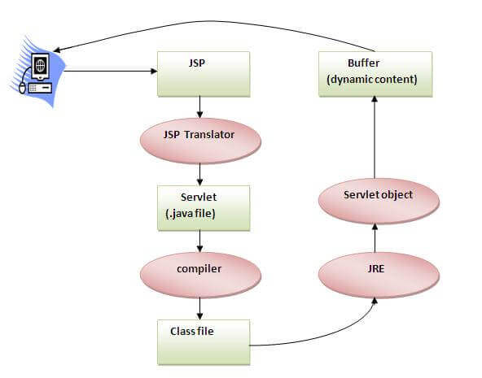

As depicted in the above diagram, JSP page is translated into Servlet by the help of JSP translator. The JSP translator is a part of the web server which is responsible for translating the JSP page into Servlet. After that, Servlet page is compiled by the compiler and gets converted into the class file. Moreover, all the processes that happen in Servlet are performed on JSP later like initialization, committing response to the browser and destroy.

### Creating a simple JSP Page

To create the first JSP page, write some HTML code as given below, and save it by .jsp extension. We have saved this file as index.jsp. Put it in a folder and paste the folder in the web-apps directory in apache tomcat to run the JSP page.

**index.jsp**

Let's see the simple example of JSP where we are using the scriptlet tag to put Java code in the JSP page. We will learn scriptlet tag later.

1. <html>
2. <body>
3. <% out.print(2*5); %>
4. </body>
5. </html>

It will print **10** on the browser.

### How to run a simple JSP Page?

Follow the following steps to execute this JSP page:

* Start the server
* Put the JSP file in a folder and deploy on the server
* Visit the browser by the URL http://localhost:portno/contextRoot/jspfile, for example, http://localhost:8888/myapplication/index.jsp

### Do I need to follow the directory structure to run a simple JSP:

No, there is no need of directory structure if you don't have class files or TLD files. For example, put JSP files in a folder directly and deploy that folder. It will be running fine. However, if you are using Bean class, Servlet or TLD file, the directory structure is required.

### The Directory structure of JSP

The directory structure of JSP page is same as Servlet. We contain the JSP page outside the WEB-INF folder or in any directory.

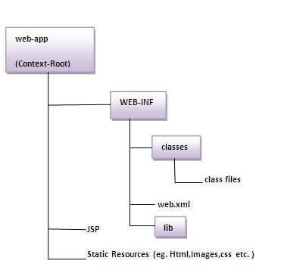

**2.8 INTRODUCTION TO MY SQL**

MySQL is an open-source relational database management system that works on many platforms. It provides multi-user access to support many storage engines and is backed by Oracle. So, you can buy a commercial license version from Oracle to get premium support services

MySQL is a relational database management system based on the Structured Query Language, which is the popular language for accessing and managing the records in the database. MySQL is open-source and free software under the GNU license. It is supported by **Oracle Company**.

Our MySQL tutorial includes all topics of MySQL database that provides for how to manage database and to manipulate data with the help of various SQL queries. These queries are: insert records, update records, delete records, select records, create tables, drop tables, etc. There are also given MySQL interview questions to help you better understand the MySQL database.

## What is Database?

It is very important to understand the database before learning MySQL. A database is an application that stores the organized collection of records. It can be accessed and manage by the user very easily. It allows us to organize data into tables, rows, columns, and indexes to find the relevant information very quickly. Each database contains distinct [API](https://www.javatpoint.com/api-full-form) for performing database operations such as creating, managing, accessing, and searching the data it stores. Today, many databases available like MySQL, Sybase, [Oracle](https://www.javatpoint.com/what-is-oracle), [MongoDB](https://www.javatpoint.com/mongodb-tutorial), [PostgreSQL](https://www.javatpoint.com/postgresql-tutorial), [SQL Server](https://www.javatpoint.com/sql-server-tutorial), etc. In this section, we are going to focus on MySQL mainly.

## What is MySQL?

MySQL is currently the most popular database management system software used for managing the relational database. It is open-source database software, which is supported by Oracle Company. It is fast, scalable, and easy to use database management system in comparison with Microsoft SQL Server and Oracle Database. It is commonly used in conjunction with [PHP](https://www.javatpoint.com/php-tutorial) scripts for creating powerful and dynamic server-side or web-based enterprise applications.

It is developed, marketed, and supported by **MySQL AB, a Swedish company**, and written in [C programming language](https://www.javatpoint.com/c-programming-language-tutorial) and [C++ programming language](https://www.javatpoint.com/cpp-tutorial). The official pronunciation of MySQL is not the My Sequel; it is **My Ess Que Ell***. However, you can pronounce it in your way.* Many small and big companies use MySQL. MySQL supports many Operating Systems like [Windows](https://www.javatpoint.com/windows), [Linux](https://www.javatpoint.com/linux-tutorial), MacOS, etc. with C, C++, and [Java languages](https://www.javatpoint.com/java-tutorial).

MySQL is a [Relational Database Management System](https://www.javatpoint.com/what-is-rdbms) (RDBMS) software that provides many things, which are as follows:

* It allows us to implement database operations on tables, rows, columns, and indexes.
* It defines the database relationship in the form of tables (collection of rows and columns), also known as relations.
* It provides the Referential Integrity between rows or columns of various tables.
* It allows us to updates the table indexes automatically.
* It uses many SQL queries and combines useful information from multiple tables for the end-users.

## How MySQL Works?

MySQL follows the working of Client-Server Architecture. This model is designed for the end-users called clients to access the resources from a central computer known as a server using network services. Here, the clients make requests through a graphical user interface (GUI), and the server will give the desired output as soon as the instructions are matched. The process of MySQL environment is the same as the client-server model.

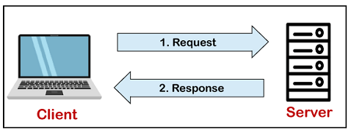

The core of the MySQL database is the MySQL Server. This server is available as a separate program and responsible for handling all the database instructions, statements, or commands. The working of MySQL database with MySQL Server are as follows:

1. MySQL creates a database that allows you to build many tables to store and manipulate data and defining the relationship between each table.
2. Clients make requests through the GUI screen or command prompt by using specific SQL expressions on MySQL.
3. Finally, the server application will respond with the requested expressions and produce the desired result on the client-side.

A client can use any MySQL [GUI](https://www.javatpoint.com/gui-full-form). But, it is making sure that your GUI should be lighter and user-friendly to make your data management activities faster and easier. Some of the most widely used MySQL GUIs are MySQL Workbench, SequelPro, DBVisualizer, and the Navicat DB Admin Tool. Some GUIs are commercial, while some are free with limited functionality, and some are only compatible with MacOS. Thus, you can choose the GUI according to your needs.

## Reasons for popularity

MySQL is becoming so popular because of these following reasons:

* MySQL is an open-source database, so you don't have to pay a single penny to use it.
* MySQL is a very powerful program that can handle a large set of functionality of the most expensive and powerful database packages.
* MySQL is customizable because it is an open-source database, and the open-source GPL license facilitates programmers to modify the SQL software according to their own specific environment.
* MySQL is quicker than other databases, so it can work well even with the large data set.
* MySQL supports many operating systems with many languages like PHP, PERL, C, C++, JAVA, etc.
* MySQL uses a standard form of the well-known SQL data language.
* MySQL is very friendly with PHP, the most popular language for web development.
* MySQL supports large databases, up to 50 million rows or more in a table. The default file size limit for a table is 4GB, but you can increase this (if your operating system can handle it) to a theoretical limit of 8 million terabytes (TB).

## History of MySQL

The project of MySQL was started in 1979 when MySQL's inventor **Michael Widenius** developed an in-house database tool called **UNIREG** for managing databases. After that, UNIREG has been rewritten in several different languages and extended to handle big databases. After some time, Michael Widenius contacted **David Hughes**, the author of mSQL, to see if Hughes would be interested in connecting mSQL to UNIREG's B+ ISAM handler to provide indexing to mSQL. That's the way MySQL came into existence.

**3.SYSTEMS DESIGN**

**3.1.SYSTEMS DESIGN**

**Systems design** is the process or art of defining the architecture, components, modules, interfaces, and data for a system to satisfy specified requirements. One could see it as the application of systems theory to product development. There is some overlap and synergy with the disciplines of systems analysis, systems architecture and systems engineering.

The input design is the link between the information system and the user. It comprises the developing specification and procedures for data preparation and those steps are necessary to put transaction data in to a usable form for processing can be achieved by inspecting the computer to read data from a written or printed document or it can occur by having people keying the data directly into the system. The design of input focuses on controlling the amount of input required, controlling the errors, avoiding delay, avoiding extra steps and keeping the process simple. The input is designed in such a way so that it provides security and ease of use with retaining the privacy. Input Design considered the following things:

* What data should be given as input?
* How the data should be arranged or coded?
* The dialog to guide the operating personnel in providing input.
* Methods for preparing input validations and steps to follow when error occur.

**OBJECTIVES**

1. Input Design is the process of converting a user-oriented description of the input into a computer-based system. This design is important to avoid errors in the data input process and show the correct direction to the management for getting correct information from the computerized system.

2. It is achieved by creating user-friendly screens for the data entry to handle large volume of data. The goal of designing input is to make data entry easier and to be free from errors. The data entry screen is designed in such a way that all the data manipulates can be performed. It also provides record viewing facilities.

3. When the data is entered it will check for its validity. Data can be entered with the help of screens. Appropriate messages are provided as when needed so that the user

will not be in maize of instant. Thus the objective of input design is to create an input layout that is easy to follow

**OUTPUT DESIGN**

A quality output is one, which meets the requirements of the end user and presents the information clearly. In any system results of processing are communicated to the users and to other system through outputs. In output design it is determined how the information is to be displaced for immediate need and also the hard copy output. It is the most important and direct source information to the user. Efficient and intelligent output design improves the system’s relationship to help user decision-making.

1. Designing computer output should proceed in an organized, well thought out manner; the right output must be developed while ensuring that each output element is designed so that people will find the system can use easily and effectively. When analysis design computer output, they should Identify the specific output that is needed to meet the requirements.

2.Select methods for presenting information.

3.Create document, report, or other formats that contain information produced by the system.

The output form of an information system should accomplish one or more of the following objectives.

* Convey information about past activities, current status or projections of the
* Future.
* Signal important events, opportunities, problems, or warnings.
* Trigger an action.
* Confirm an action.

**INTRODUCTION**

**Purpose and Scope**

This section provides a brief description of the Systems Design Document’s purpose and scope.

**Project Executive Summary**

This section provides a description of the project from a management perspective and an overview of the framework within which the conceptual system design was prepared. If appropriate, include the information discussed in the subsequent sections in the summary.

System Overview

This section describes the system in narrative form using non-technical terms. It should provide a high-level system architecture diagram showing a subsystem breakout of the system, if applicable. The high-level system architecture or subsystem diagrams should, if applicable, show interfaces to external systems. Supply a high-level context diagram for the system and subsystems, if applicable. Refer to the requirements trace ability matrix (RTM) in the Functional Requirements Document (FRD), to identify the allocation of the functional requirements into this design document.

Design Constraints

This section describes any constraints in the system design (reference any trade-off analyses conducted such, as resource use versus productivity, or conflicts with other systems) and includes any assumptions made by the project team in developing the system design.

Future Contingencies

This section describes any contingencies that might arise in the design of the system that may change the development direction. Possibilities include lack of interface agreements with outside agencies or unstable architectures at the time this document is produced. Address any possible workarounds or alternative plans.

**Document Organization**

This section describes the organization of the Systems Design Document.

**Points of Contact**

This section provides the organization code and title of the key points of contact (and alternates if appropriate) for the information system development effort. These points of contact should include the Project Manager, System Proponent, User Organization, Quality Assurance (QA) Manager, Security Manager, and Configuration Manager, as appropriate.

**Project References**

This section provides a bibliography of key project references and deliverables that have been produced before this point.

**Glossary**

Supply a glossary of all terms and abbreviations used in this document. If the glossary is several pages in length, it may be included as an appendix.

**SYSTEM ARCHITECTURE**

In this section, describe the system and/or subsystem(s) architecture for the project. References to external entities should be minimal, as they will be described in detail in Section 6, External Interfaces.

**System Hardware Architecture**

In this section, describe the overall system hardware and organization. Include a list of hardware components (with a brief description of each item) and diagrams showing the connectivity between the components. If appropriate, use subsections to address each subsystem.

**System Software Architecture**

In this section, describe the overall system software and organization. Include a list of software modules (this could include functions, subroutines, or classes), computer languages, and programming computer-aided software engineering tools (with a brief description of the function of each item). Use structured organization diagrams/object-oriented diagrams that show the various segmentation levels down to the lowest level. All features on the diagrams should have reference numbers and names. Include a narrative that expands on and enhances the understanding of the functional breakdown. If appropriate, use subsections to address each module.

**Note:** The diagrams should map to the FRD data flow diagrams, providing the physical process and data flow related to the FRD logical process and data flow.

**Internal Communications Architecture**

In this section, describe the overall communications within the system; for example, LANs, buses, etc. Include the communications architecture(s) being implemented, such as X.25, Token Ring, etc. Provide a diagram depicting the communications path(s) between the system and subsystem modules. If appropriate, use subsections to address each architecture being employed.

**Note:** The diagrams should map to the FRD context diagrams.

**FILE AND DATABASE DESIGN**

Interact with the Database Administrator (DBA) when preparing this section. The section should reveal the final design of all database management system (DBMS) files and the non-DBMS files associated with the system under development. Additional information may add as required for the particular project. Provide a comprehensive data dictionary showing data element name, type, length, source, validation rules, maintenance (create, read, update, delete (CRUD) capability), data stores, outputs, aliases, and description. Can be included as an appendix.

**Database Management System Files**

This section reveals the final design of the DBMS files and includes the following information, as appropriate (refer to the data dictionary):

* Refined logical model; provide normalized table layouts, entity relationship diagrams, and other logical design information
* A physical description of the DBMS schemas, sub-schemas, records, sets, tables, storage page sizes, etc.
* Access methods (such as indexed, via set, sequential, random access, sorted pointer array, etc.)
* Estimate of the DBMS file size or volume of data within the file, and data pages, including overhead resulting from access methods and free space
* Definition of the update frequency of the database tables, views, files, areas, records, sets, and data pages; estimate the number of transactions if the database is an online transaction-based system

**Non-Database Management System Files**

In this section, provide the detailed description of all non-DBMS files and include a narrative description of the usage of each file—including if the file is used for input, output, or both; if this file is a temporary file; an indication of which modules read and write the file, etc.; and file structures (refer to the data dictionary). As appropriate, the file structure information should:

* Identify record structures, record keys or indexes, and reference data elements within the records
* Define record length (fixed or maximum variable length) and blocking factors
* Define file access method—for example, index sequential, virtual sequential, random access, etc.
* Estimate the file size or volume of data within the file, including overhead resulting from file access methods
* Define the update frequency of the file; if the file is part of an online transaction-based system, provide the estimated number of transactions per unit time, and the statistical mean, mode, and distribution of those transactions

**HUMAN-MACHINE INTERFACE**

This section provides the detailed design of the system and subsystem inputs and outputs relative to the user/operator. Any additional information may be added to this section and may be organized according to whatever structure best presents the operator input and output designs. Depending on the particular nature of the project, it may be appropriate to repeat these sections at both the subsystem and design module levels. Additional information may be added to the subsections if the suggested lists are inadequate to describe the project inputs and outputs.

**Inputs**

This section is a description of the input media used by the operator for providing information to the system; show a mapping to the high-level data flows described in Section 1 .2.1, System Overview. For example, data entry screens, optical character readers, bar scanners, etc. If appropriate, the input record types, file structures, and database structures provided in Section 3, File and Database Design, may be referenced. Include data element definitions, or refer to the data dictionary.

Provide the layout of all input data screens or graphical user interfaces (GUTs) (for example, windows). Provide a graphic representation of each interface. Define all data elements associated with each screen or GUI, or reference the data dictionary.

This section should contain edit criteria for the data elements, including specific values, range of values, mandatory/optional, alphanumeric values, and length. Also address data entry controls to prevent edit bypassing.

Discuss the miscellaneous messages associated with operator inputs, including the following:

* Copies of form(s) if the input data are keyed or scanned for data entry from printed forms
* Description of any access restrictions or security considerations
* Each transaction name, code, and definition, if the system is a transaction-based processing system

**Outputs**

This section describes of the system output design relative to the user/operator; show a mapping to the high-level data flows described in Section 1.2.1. System outputs include reports, data display screens and GUIs, query results, etc. The output files are described in Section 3 and may be referenced in this section. The following should be provided, if appropriate:

* Identification of codes and names for reports and data display screens
* Description of report and screen contents (provide a graphic representation of each layout and define all data elements associated with the layout or reference the data dictionary)
* Description of the purpose of the output, including identification of the primary users
* Report distribution requirements, if any (include frequency for periodic reports)
* Description of any access restrictions or security considerations

**DETAILED DESIGN**

This section provides the information needed for a system development team to actually build and integrate the hardware components, code and integrate the software modules, and interconnect the hardware and software segments into a functional product. Additionally, this section addresses the detailed procedures for combining separate COTS packages into a single system. Every detailed requirement should map back to the FRD, and the mapping should be presented in an update to the RTM and include the RTM as an appendix to this design document.

**Hardware Detailed Design**

A hardware component is the lowest level of design granularity in the system. Depending on the design requirements, there may be one or more components per system. This section should provide enough detailed information about individual component requirements to correctly build and/or procure all the hardware for the system (or integrate COTS items).

If there are many components or if the component documentation is extensive, place it in an appendix or reference a separate document. Add additional diagrams and information, if necessary, to describe each component and its functions, adequately. Industry-standard component specification practices should be followed. For COTS procurements, if a specific vendor has been identified, include appropriate item names. Include the following information in the detailed component designs (as applicable):

* Power input requirements for each component
* Signal impedances and logic states
* Connector specifications (serial/parallel, 11-pin, male/female, etc.)
* Memory and/or storage space requirements
* Processor requirements (speed and functionality)
* Graphical representation depicting the number of hardware items (for example, monitors, printers, servers, I/O devices), and the relative positioning of the components to each other
* Cable type(s) and length(s)
* User interfaces (buttons, toggle switches, etc.)
* Hard drive/floppy drive/CD-ROM requirements
* Monitor resolution

**Software Detailed Design**

A software module is the lowest level of design granularity in the system. Depending on the software development approach, there may be one or more modules per system. This section should provide enough detailed information about logic and data necessary to completely write source code for all modules in the system (and/or integrate COTS software programs).

If there are many modules or if the module documentation is extensive, place it in an appendix or reference a separate document. Add additional diagrams and information, if necessary, to describe each module, its functionality, and its hierarchy. Industry-standard module specification practices should be followed. Include the following information in the detailed module designs:

* A narrative description of each module, its function(s), the conditions under which it is used (called or scheduled for execution), its overall processing, logic, interfaces to other modules, interfaces to external systems, security requirements, etc.; explain any algorithms used by the module in detail
* For COTS packages, specify any call routines or bridging programs to integrate the package with the system and/or other COTS packages (for example, Dynamic Link Libraries)
* Data elements, record structures, and file structures associated with module input and output
* Graphical representation of the module processing, logic, flow of control, and algorithms, using an accepted diagramming approach (for example, structure charts, action diagrams, flowcharts, etc.)
* Data entry and data output graphics; define or reference associated data elements; if the project is large and complex or if the detailed module designs will be incorporated into a separate document, then it may be appropriate to repeat the screen information in this section
* Report layout

**Internal Communications Detailed Design**

If the system includes more than one component there may be a requirement for internal communications to exchange information, provide commands, or support input/output functions. This section should provide enough detailed information about the communication requirements to correctly build and/or procure the communications components for the system. Include the following information in the detailed designs (as appropriate):

* The number of servers and clients to be included on each area network
* Specifications for bus timing requirements and bus control
* Format(s) for data being exchanged between components
* Graphical representation of the connectivity between components, showing the direction of data flow (if applicable), and approximate distances between components; information should provide enough detail to support the procurement of hardware to complete the installation at a given location
* LAN topology

**EXTERNAL INTERFACES**

External systems are any systems that are not within the scope of the system under development, regardless whether the other systems are managed by the State or another agency. In this section, describe the electronic interface(s) between this system and each of the other systems and/or subsystem(s), emphasizing the point of view of the system being developed.

**Interface Architecture**

In this section, describe the interface(s) between the system being developed and other systems; for example, batch transfers, queries, etc. Include the interface architecture(s) being implemented, such as wide area networks, gateways, etc. Provide a diagram depicting the communications path(s) between this system and each of the other systems, which should map to the context diagrams in Section 1.2.1. If appropriate, use subsections to address each interface being implemented.

**Interface Detailed Design**

For each system that provides information exchange with the system under development, there is a requirement for rules governing the interface. This section should provide enough detailed information about the interface requirements to correctly format, transmit, and/or receive data across the interface. Include the following information in the detailed design for each interface (as appropriate):

* The data format requirements; if there is a need to reformat data before they are transmitted or after incoming data is received, tools and/or methods for the reformat process should be defined
* Specifications for hand-shaking protocols between the two systems; include the content and format of the information to be included in the hand-shake messages, the timing for exchanging these messages, and the steps to be taken when errors are identified
* Format(s) for error reports exchanged between the systems; should address the disposition of error reports; for example, retained in a file, sent to a printer, flag/alarm sent to the operator, etc.
* Graphical representation of the connectivity between systems, showing the direction of data flow
* Query and response descriptions

If a formal Interface Control Document (ICD) exists for a given interface, the information can be copied, or the ICD can be referenced in this section.

**SYSTEM INTEGRITY CONTROLS**

Sensitive systems use information for which the loss, misuse, modification of, or unauthorized access to that information could affect the conduct of State programs, or the privacy to which individuals are entitled.

Developers of sensitive State systems are required to develop specifications for the following minimum levels of control:

* Internal security to restrict access of critical data items to only those access types required by users
* Audit procedures to meet control, reporting, and retention period requirements for operational and management reports
* Application audit trails to dynamically audit retrieval access to designated critical data
* Standard Tables to be used or requested for validating data fields
* Verification processes for additions, deletions, or updates of critical data

Ability to identify all audit information by user identification, network terminal identification, date, time, and data accessed or change.

**DATA FLOW DIAGRAM:**

1. The DFD is also called as bubble chart. It is a simple graphical formalism that can be used to represent a system in terms of input data to the system, various processing carried out on this data, and the output data is generated by this system.

2. The data flow diagram (DFD) is one of the most important modeling tools. It is used to model the system components. These components are the system process, the data used by the process, an external entity that interacts with the system and the information flows in the system.

3. DFD shows how the information moves through the system and how it is modified by a series of transformations. It is a graphical technique that depicts information flow and the transformations that are applied as data moves from input to output.

4. DFD is also known as bubble chart. A DFD may be used to represent a system at any level of abstraction. DFD may be partitioned into levels that represent increasing information flow and functional

**SYSTEM DESIGN :(** Admin**)**



**USER**



**UML DIAGRAMS**

UML stands for Unified Modeling Language. UML is a standardized general-purpose modeling language in the field of object-oriented software engineering. The standard is managed, and was created by, the Object Management Group.

The goal is for UML to become a common language for creating models of object oriented computer software. In its current form UML is comprised of two major components: a Meta-model and a notation. In the future, some form of method or process may also be added to; or associated with, UML.

The Unified Modeling Language is a standard language for specifying, Visualization, Constructing and documenting the artifacts of software system, as well as for business modeling and other non-software systems.

The UML represents a collection of best engineering practices that have proven successful in the modeling of large and complex systems.

The UML is a very important part of developing objects oriented software and the software development process. The UML uses mostly graphical notations to express the design of software projects.

**GOALS:**

The Primary goals in the design of the UML are as follows:

1. Provide users a ready-to-use, expressive visual modeling Language so that they can develop and exchange meaningful models.

2. Provide extendibility and specialization mechanisms to extend the core concepts.

3. Be independent of particular programming languages and development process.

4. Provide a formal basis for understanding the modeling language.

5. Encourage the growth of OO tools market.

6. Support higher level development concepts such as collaborations, frameworks, patterns and components.

7. Integrate best practices.

**USE CASE DIAGRAM:**

A use case diagram in the Unified Modeling Language (UML) is a type of behavioral diagram defined by and created from a Use-case analysis. Its purpose is to present a graphical overview of the functionality provided by a system in terms of actors, their goals (represented as use cases), and any dependencies between those use cases. The main purpose of a use case diagram is to show what system functions are performed for whic actor. Roles of the actors in the system can be depicted.



**CLASS DIAGRAM:**

In software engineering, a class diagram in the Unified Modeling Language (UML) is a type of static structure diagram that describes the structure of a system by showing the system's classes, their attributes, operations (or methods), and the relationships among the classes. It explains which class contains information



**ACTIVITY DIAGRAM**



**SEQUENCE DIAGRAM:**

A sequence diagram in Unified Modeling Language (UML) is a kind of interaction diagram that shows how processes operate with one another and in what order. It is a construct of a Message Sequence Chart. Sequence diagrams are sometimes called event diagrams, event scenarios, and timing diagram.



**3.2 FORM DESIGN**

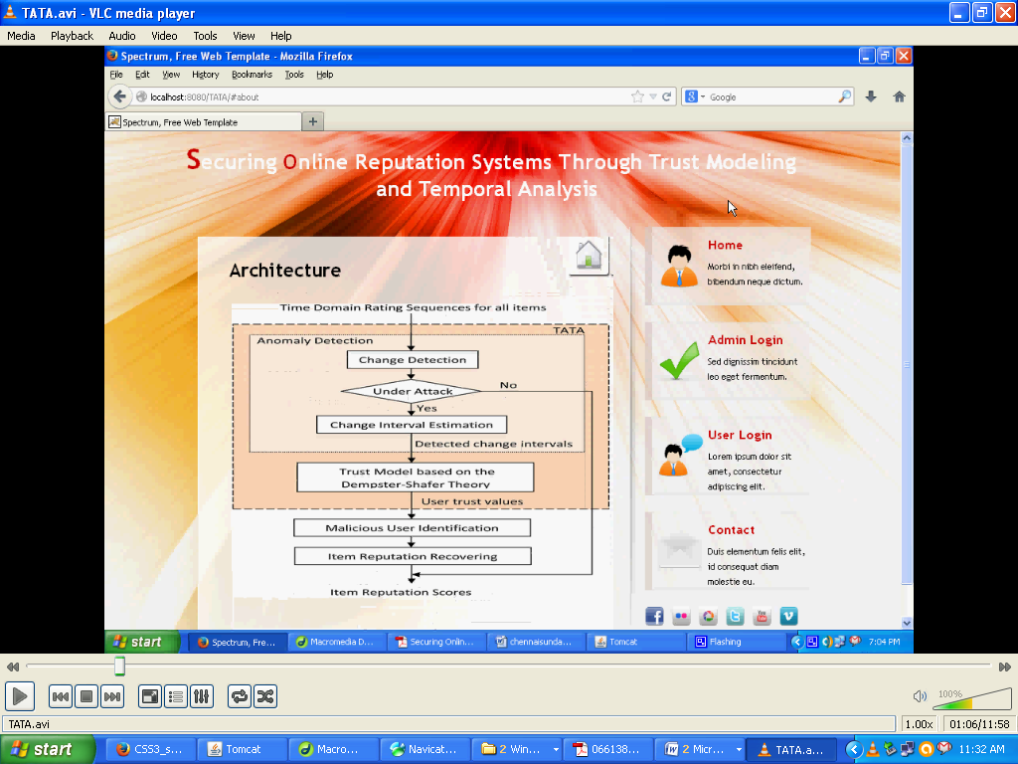

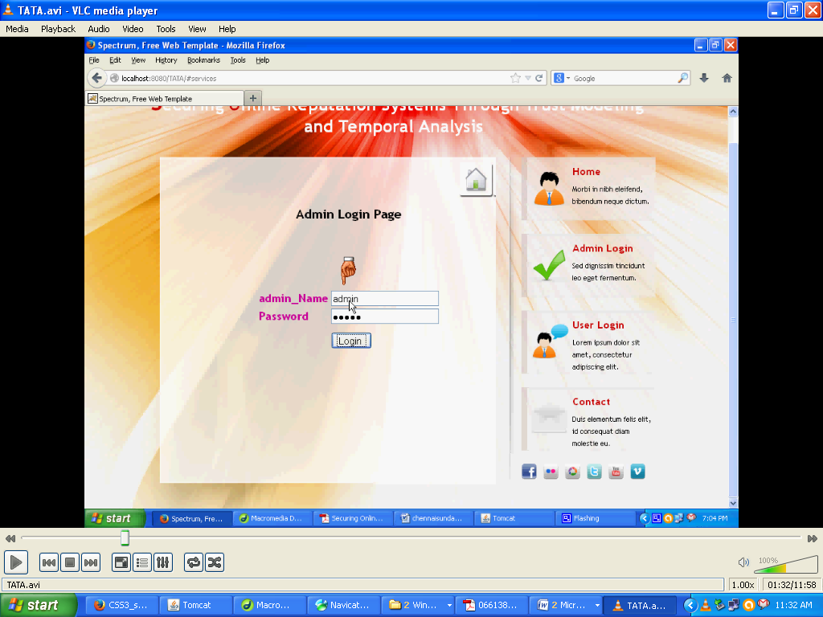

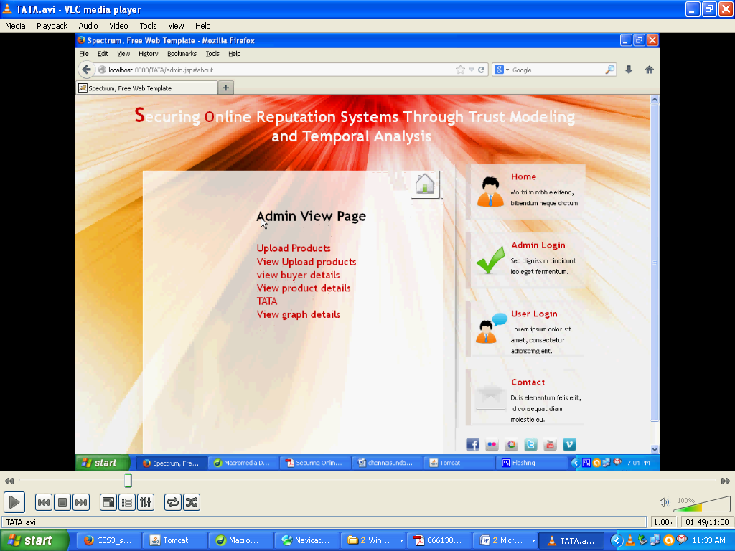

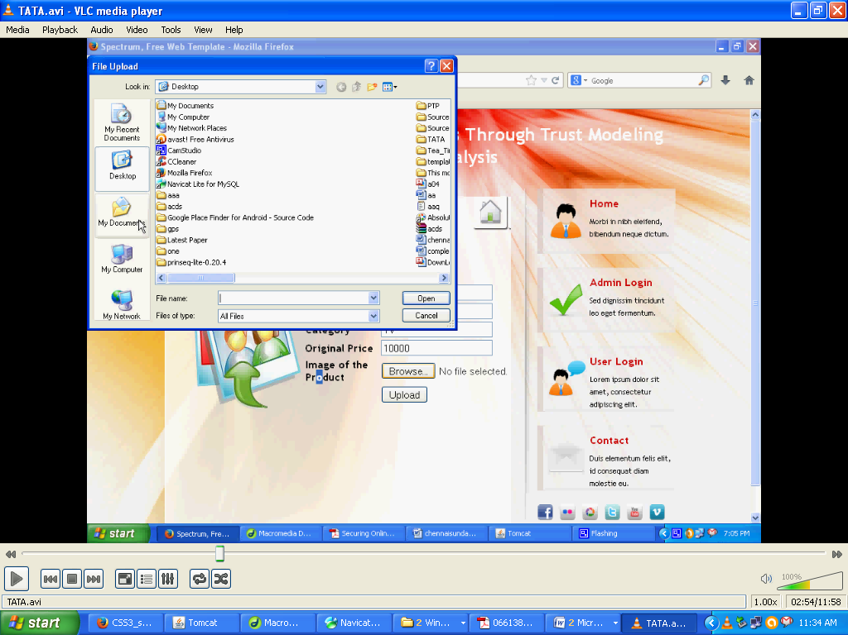

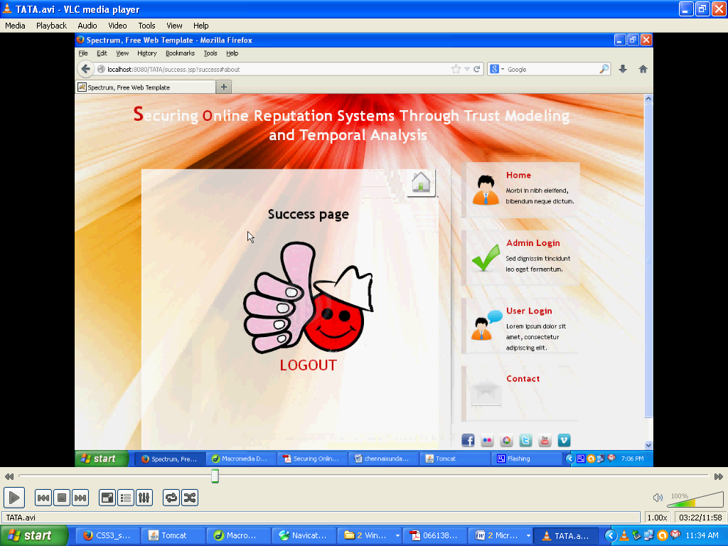

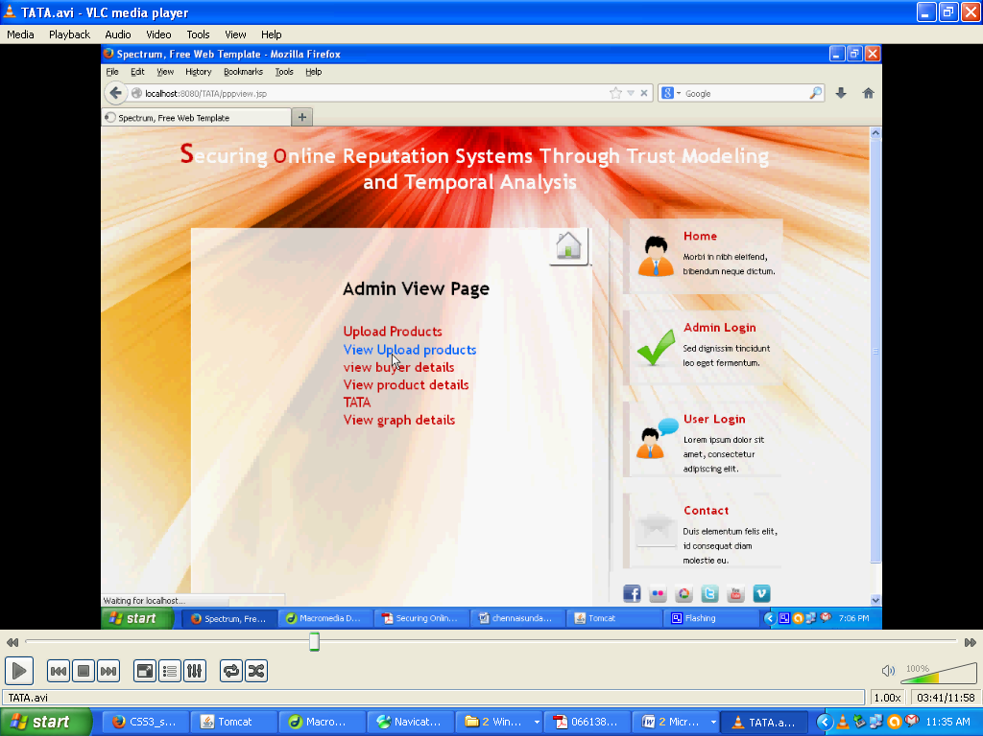

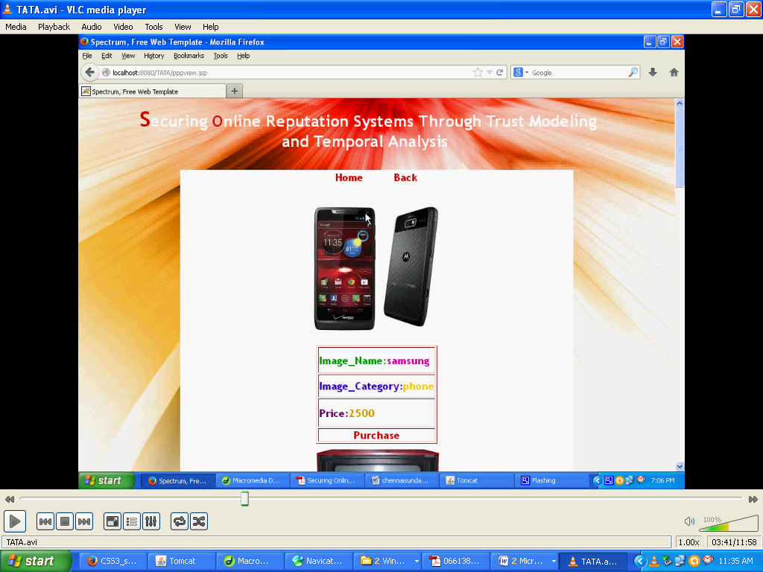

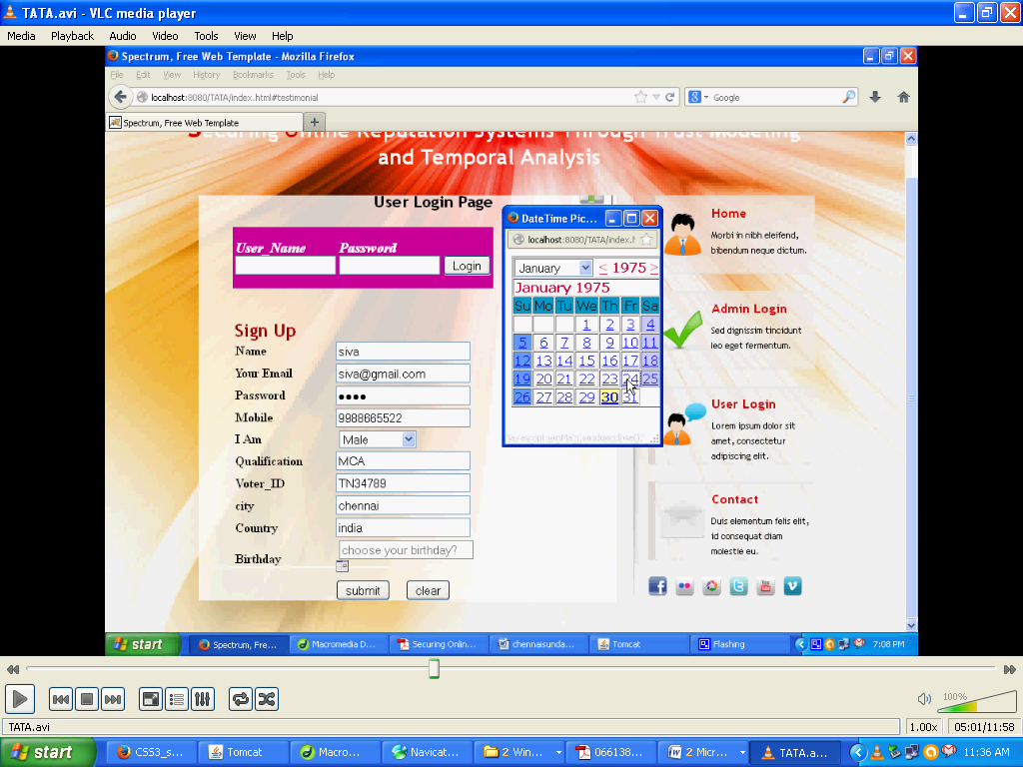



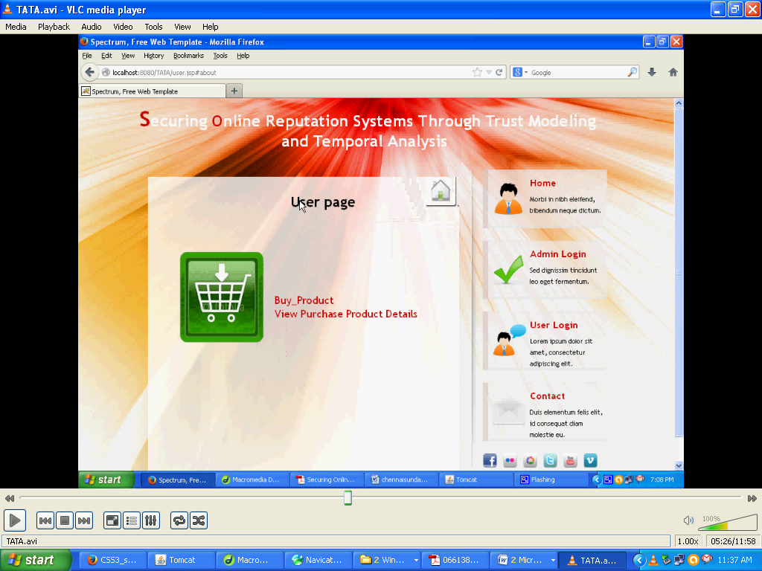

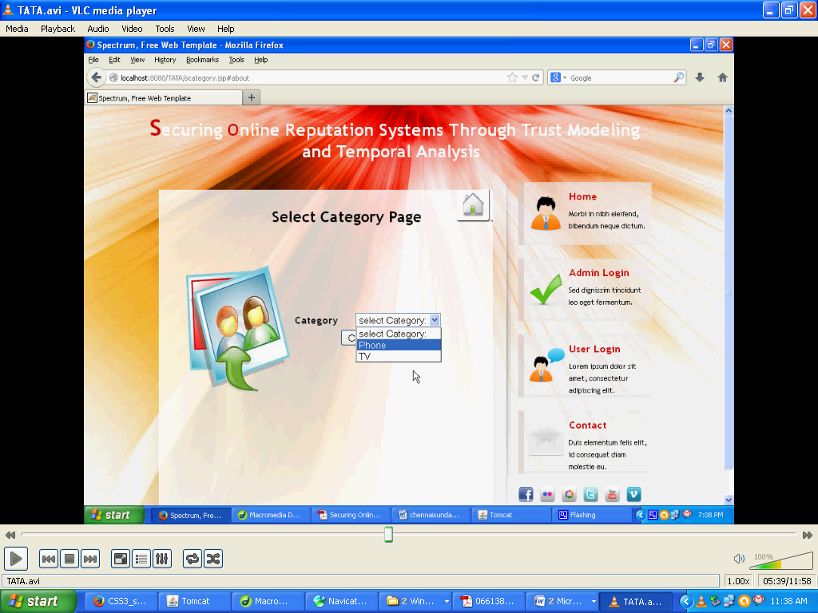

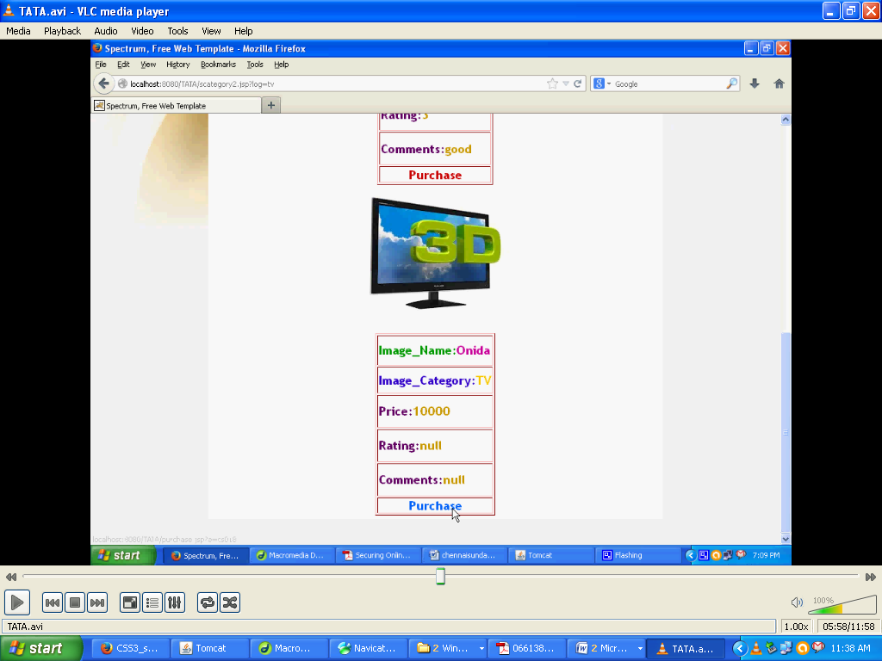

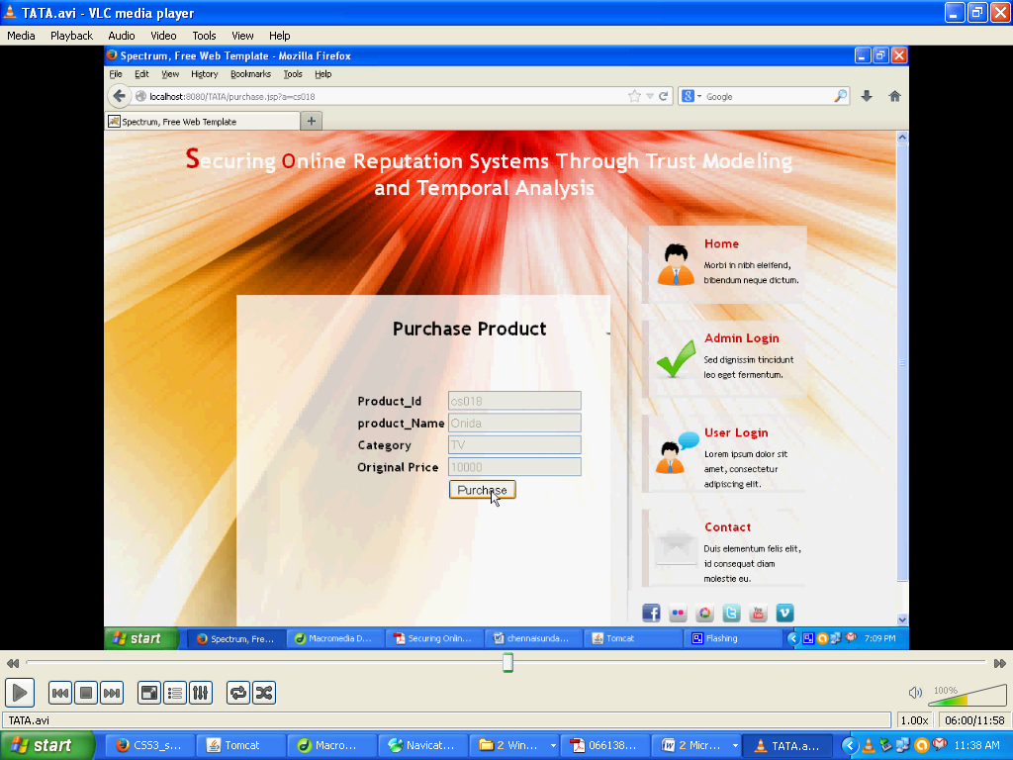

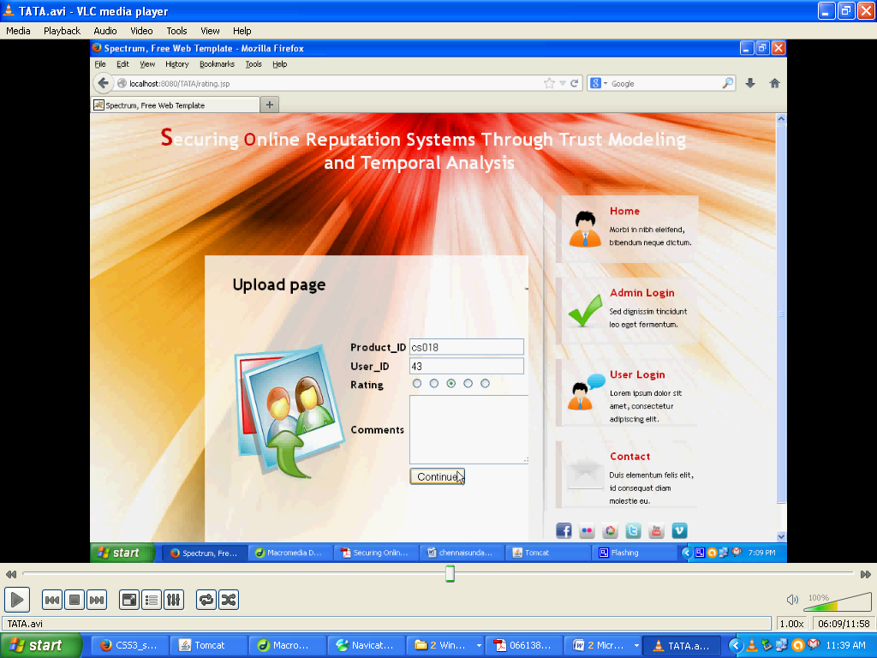

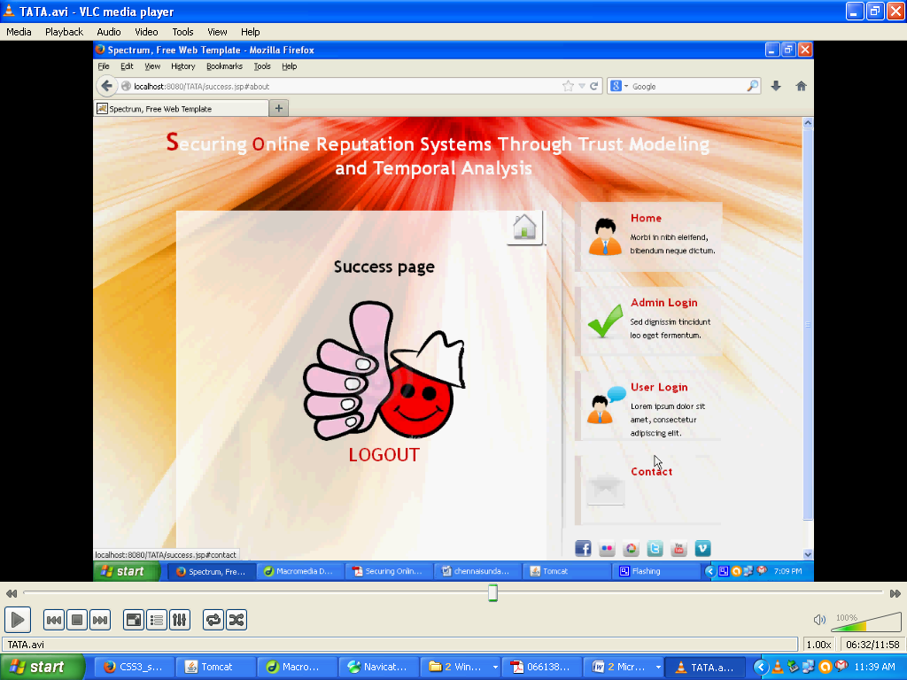

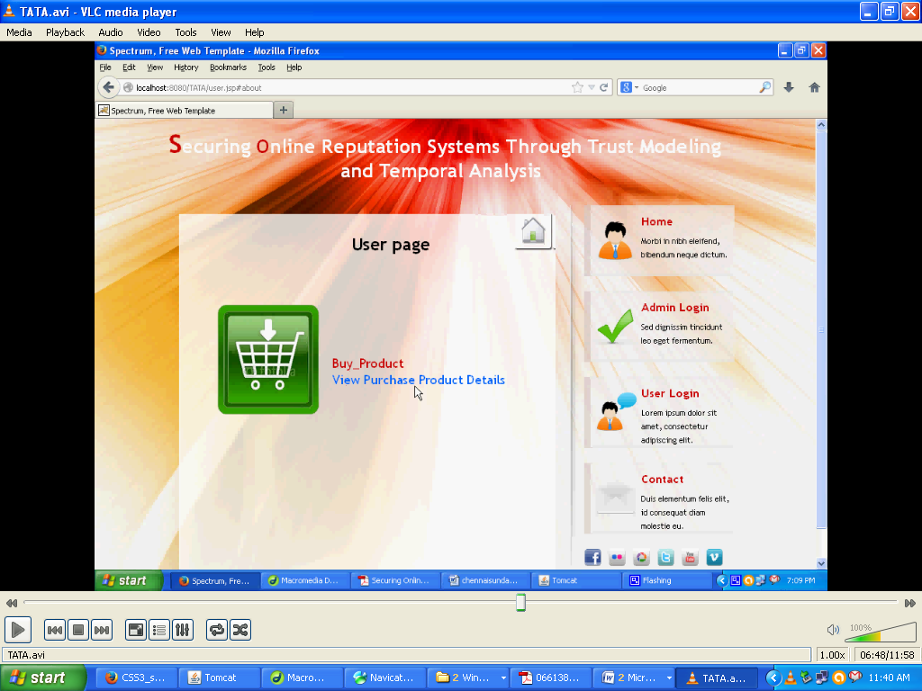

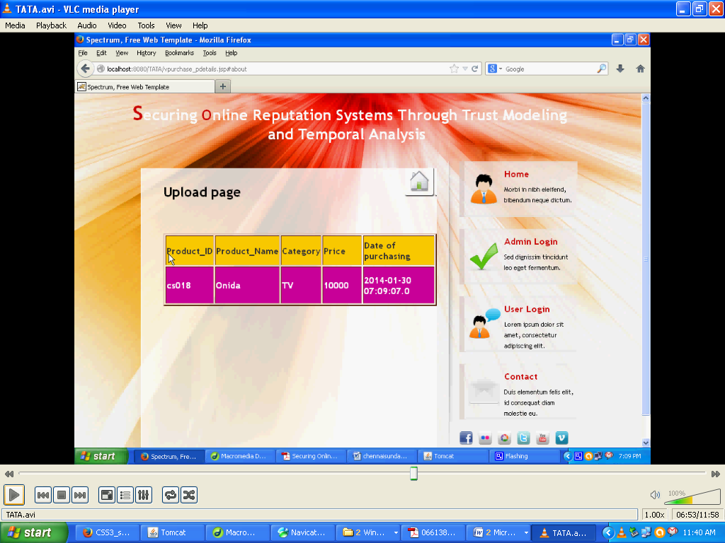

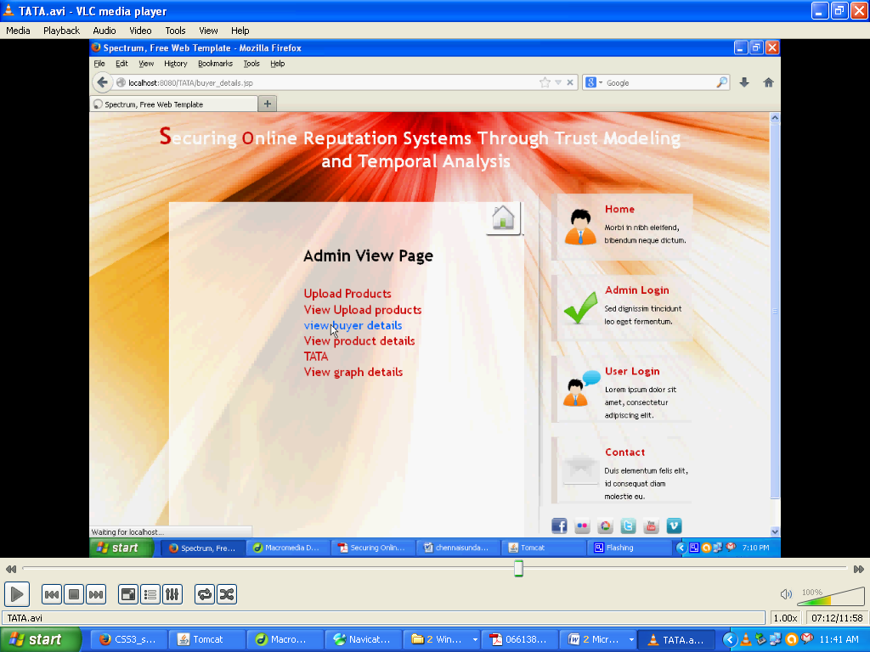

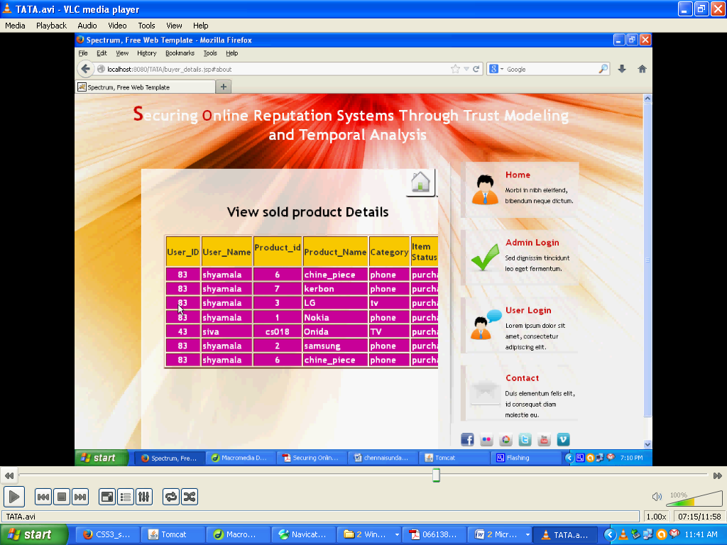

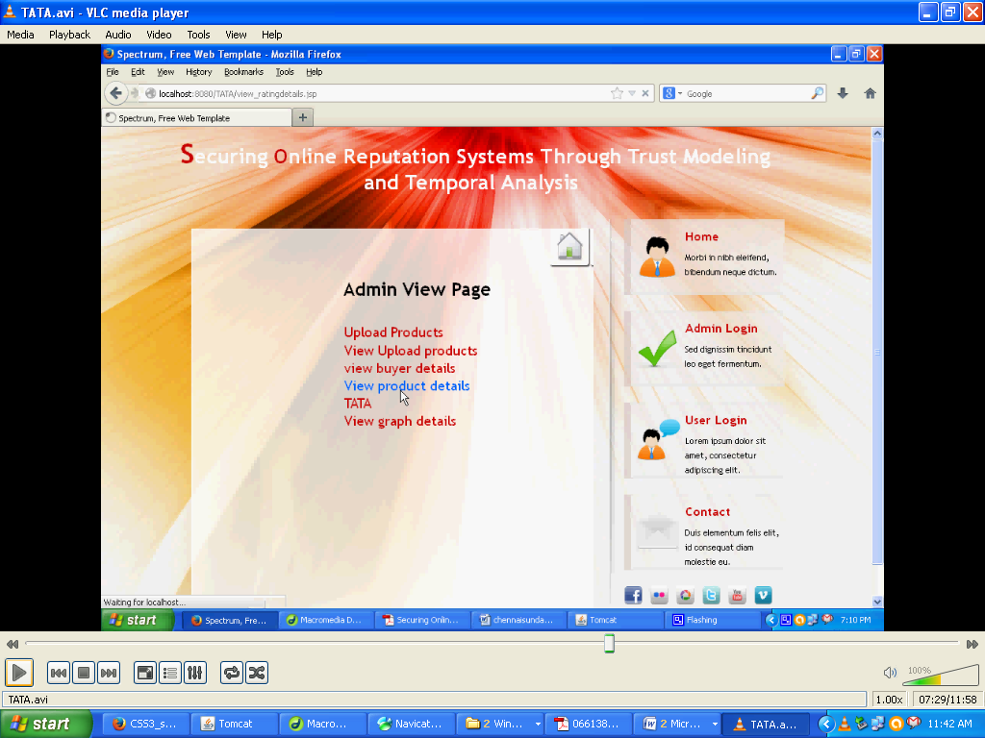

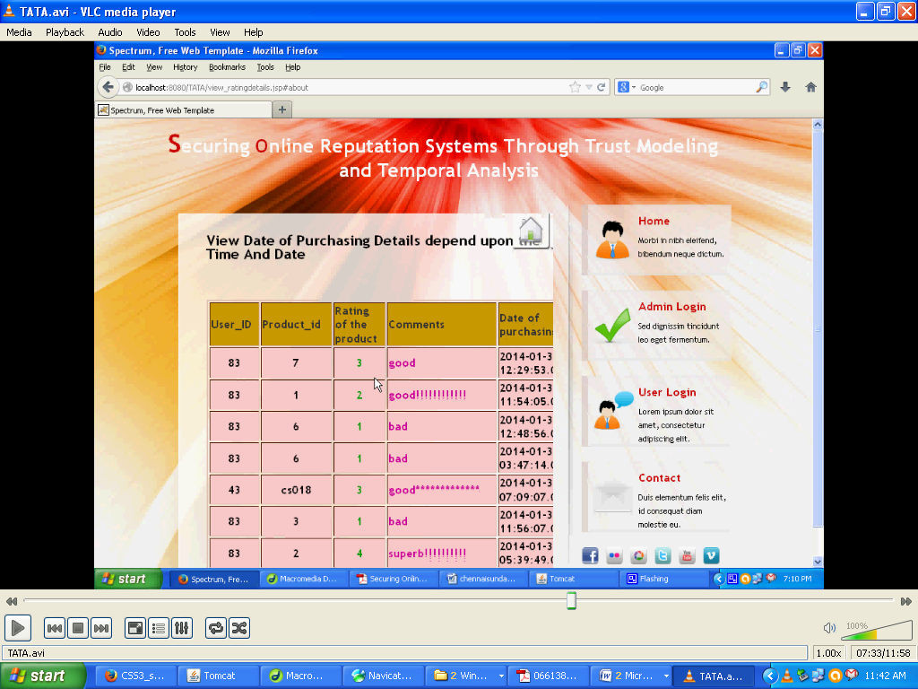

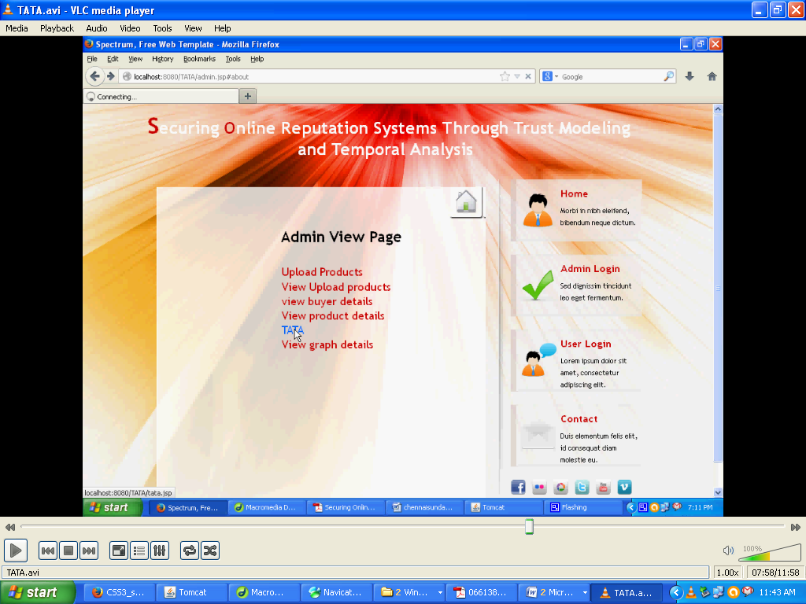

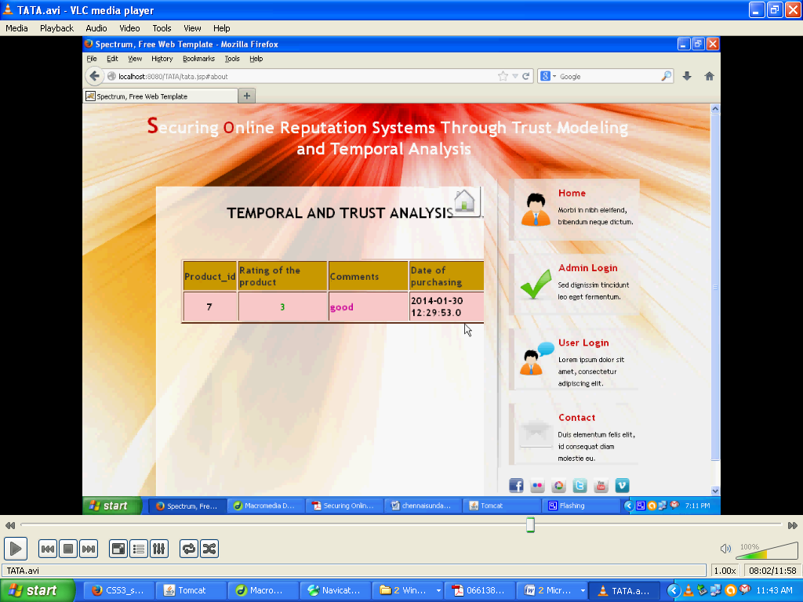

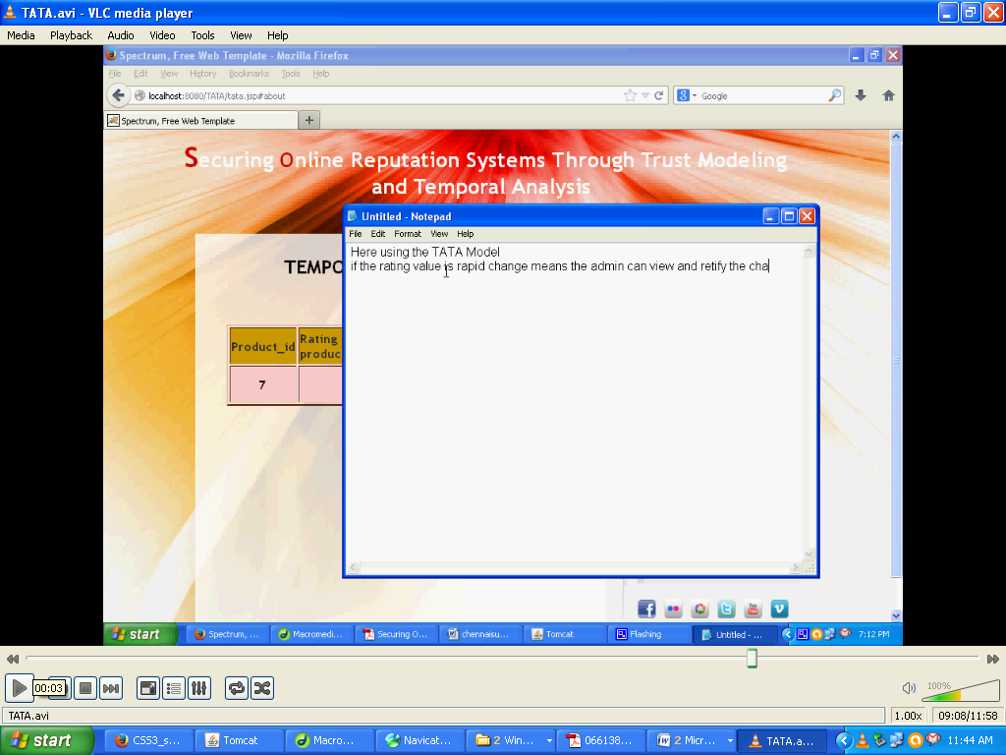

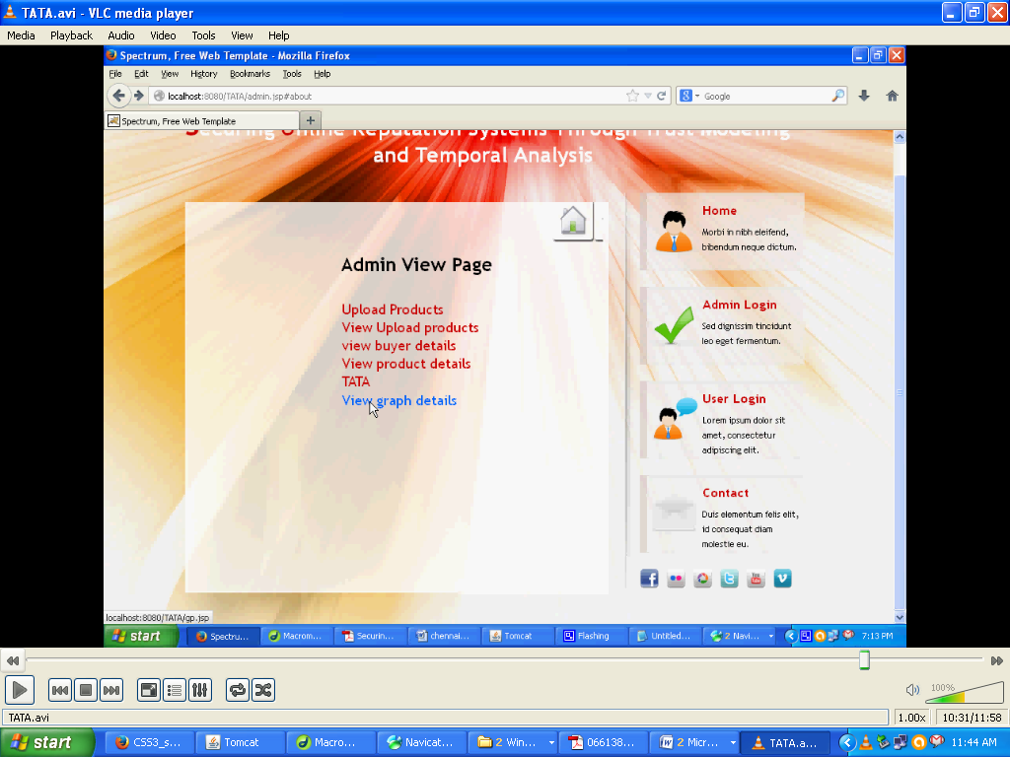

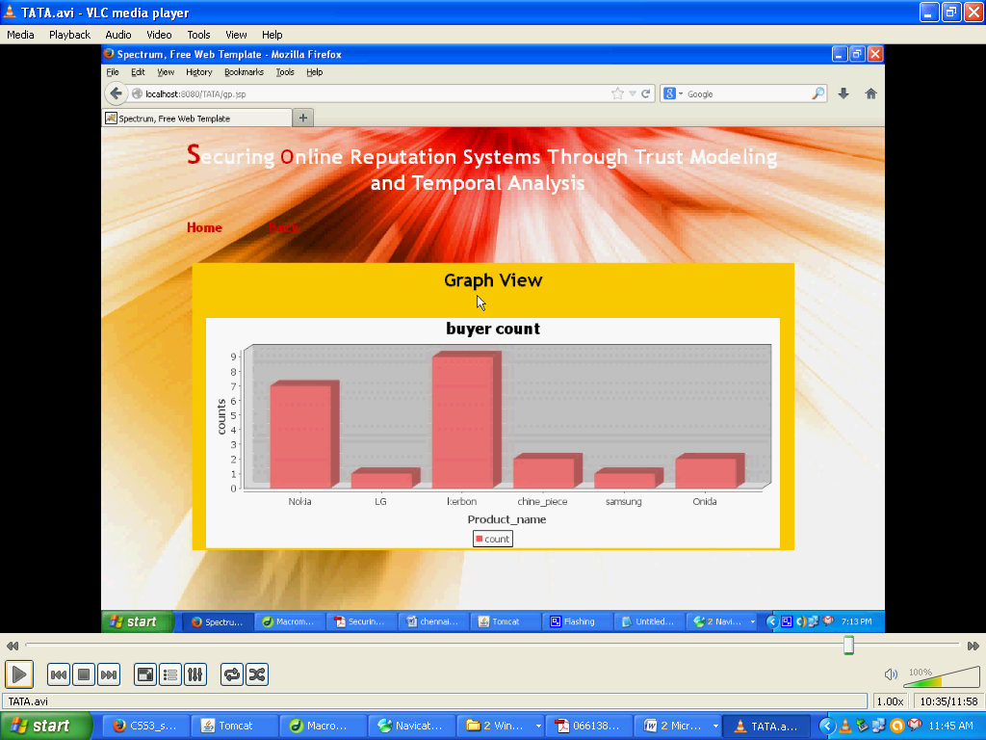

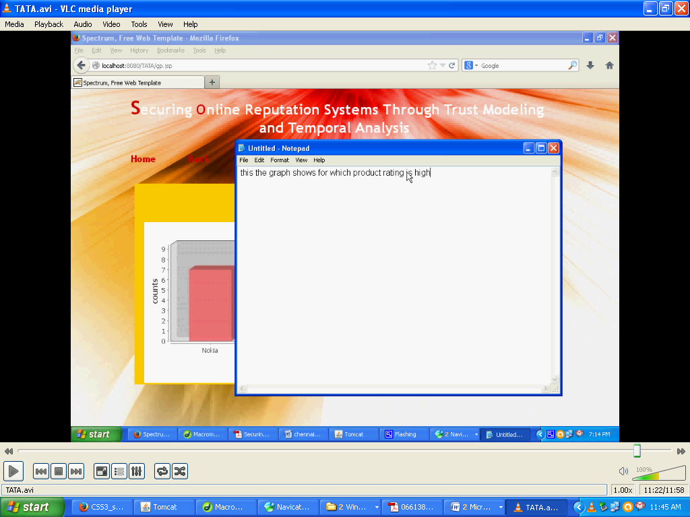

**4.SYSTEM TESTING**

**4.1. INTRODUCTION TO TESTING**

The purpose of testing is to discover errors. Testing is the process of trying to discover every conceivable fault or weakness in a work product. It provides a way to check the functionality of components, sub assemblies, assemblies and/or a finished product It is the process of exercising software with the intent of ensuring that theSoftware system meets its requirements and user expectations and does not fail in an unacceptable manner. There are various types of test. Each test type addresses a specific testing requirement.

**4.2.TYPES OF TESTS**

**Unit testing**

Unit testing involves the design of test cases that validate that the internal program logic is functioning properly, and that program inputs produce valid outputs. All decision branches and internal code flow should be validated. It is the testing of individual software units of the application .it is done after the completion of an individual unit before integration. This is a structural testing, that relies on knowledge of its construction and is invasive. Unit tests perform basic tests at component level and test a specific business process, application, and/or system configuration. Unit tests ensure that each unique path of a business process performs accurately to the documented specifications and contains clearly defined inputs and expected results.

**Integration testing**

Integration tests are designed to test integrated software components to determine if they actually run as one program. Testing is event driven and is more concerned with the basic outcome of screens or fields. Integration tests demonstrate that although the components were individually satisfaction, as shown by successfully unit testing, the combination of components is correct and consistent. Integration testing is specifically aimed at exposing the problems that arise from the combination of components.

**Functional test**

Functional tests provide systematic demonstrations that functions tested are available as specified by the business and technical requirements, system documentation, and user manuals.

Functional testing is centered on the following items:

Valid Input : identified classes of valid input must be accepted.

Invalid Input : identified classes of invalid input must be rejected.

Functions : identified functions must be exercised.

Output : identified classes of application outputs must be exercised.

Systems/Procedures: interfacing systems or procedures must be invoked.

Organization and preparation of functional tests is focused on requirements, key functions, or special test cases. In addition, systematic coverage pertaining to identify Business process flows; data fields, predefined processes, and successive processes must be considered for testing. Before functional testing is complete, additional tests are identified and the effective value of current tests is determined.

**System Test**

System testing ensures that the entire integrated software system meets requirements. It tests a configuration to ensure known and predictable results. An example of system testing is the configuration oriented system integration test. System testing is based on process descriptions and flows, emphasizing pre-driven process links and integration points.

**White Box Testing**

White Box Testing is a testing in which in which the software tester has knowledge of the inner workings, structure and language of the software, or at least its purpose. It is purpose. It is used to test areas that cannot be reached from a black box level.

***Black Box Testing***

Black Box Testing is testing the software without any knowledge of the inner workings, structure or language of the module being tested. Black box tests, as most other kinds of tests, must be written from a definitive source document, such as specification or requirements document, such as specification or requirements document. It is a testing in which the software under test is treated, as a black box .you cannot “see” into it. The test provides inputs and responds to outputs without considering how the software works.

**Unit Testing:**

Unit testing is usually conducted as part of a combined code and unit test phase of the software lifecycle, although it is not uncommon for coding and unit testing to be conducted as two distinct phases.

**Test strategy and approach**

Field testing will be performed manually and functional tests will be written in detail.

**Test objectives**

* All field entries must work properly.
* Pages must be activated from the identified link.
* The entry screen, messages and responses must not be delayed.

**Features to be tested**

* Verify that the entries are of the correct format
* No duplicate entries should be allowed
* All links should take the user to the correct page.

# Integration Testing

Software integration testing is the incremental integration testing of two or more integrated software components on a single platform to produce failures caused by interface defects.

The task of the integration test is to check that components or software applications, e.g. components in a software system or – one step up – software applications at the company level – interact without error.

**Test Results:** All the test cases mentioned above passed successfully. No defects encountered.

**5.CONCLUSION**

The Internet has created vast opportunities for online interactions. However, due to the anonymity of the Internet, it is very difﬁcult for normal users to evaluate a stranger’s trustworthiness and quality, which makes online interactions risky. Is a piece of news on Reddit true? Does a product atAmazon.com have high quality as described? Is a video on YouTube really interesting or informative? In most cases, the answers can hardly be predicted before the interactions are committed. The problem is how the online participants protect themselves by judging the quality of strangers or unfamiliar items beforehand. The objective of the proposed scheme is to detect the malicious users who provide dishonest ratings; recover reputation score of the target item, that receives dishonest ratings; avoid interference to normal items’ reputation scores. Speciﬁcally, TATA is a combination of an anomaly detector,

**6.BIBLIOGRAPHY**

R. Buyya, C. S. Yeo, S. Venugopal, J. Broberg, and I. Brandic, “Cloud Computing and Emerging IT Platforms: Vision, Hype, and Reality for Delivering Computing as the 5th Utility”, *Future* *Generation Computer Systems,* vol. 25, no. 6, pp. 599-616, 2009.

T. Rings, G. Caryer, J. Gallop, J. Grabowski, T. Kovacikova, S. Schulz and I. Stokes-Rees, “Grid and Cloud Computing: Opportunities for Integration with the Next Generation Network”, *J Grid Computing*, vol. 7, no. 3, pp. 1572-9814, 2009.

M. Armbrust, “Above the Clouds: A Berkeley View of Cloud Computing”, Tech. Rep. UCB/EECS-2009-28, EECS Department, U.C. Berkeley, 2009.

Thomas Erl, “*Service-Oriented Architecture: Concepts, Technology, and Design”*, Prentice Hall, NJ, USA, 2005

Josuttis, N M., “*SOA in Practice*”, O’Reilly. 2007

G. Horgan and S. Khaddaj, "Use of an Adaptable Quality Model in a Production Support Environment", *Systems and Software*, vol. 82, pp. 730–738, 2009.

S. Khaddaj, "Quality of Service Issues in Distributed Component Based Environments", *Algorithms and Computational Technology*, vol. 4, pp. 523-531, 2010.

S. Khaddaj and G. Horgan, "The Evaluation of Software Quality Factors in Very Large Information Systems", *E-Journal of Information* *Systems Evaluation,* vol. 7, pp. 43-48, 2004.

S. Khaddaj and H Nguyen, "*Cloud Computing: The Management of Service Level Agreements*", SEEC’1010, pp. 24-31, 2010.

V. Stantchev and C. Schröpfer, “*Negotiating and Enforcing QoS and SLAs in Grid and Cloud Computing*”, GPC, pp. 25-35, 2009.